**HR ANALYTICS: VISUALIZING EMPLOYEE ATTRITION DRIVERS**

**Presented By: Group 5**

Sibangi Subhadarsani (ID: 11803711)

Neola D’Sa (ID: 11809662)

Shravya Thangamma Kechamada Sharath (ID:11822010)

Shreenaben Patel (ID: 11825053)

Vindhya Kakkad (ID: 11844583)

**Course Name: DSCI 5360 Section 005 - Data Visualization**

**University: University of North Texas**

**Date: 12/06/2025**

**Introduction & Background**

**Motivation:** Employee attrition is a significant and costly challenge for organizations worldwide. The loss of an employee results in direct costs related to recruitment and training for a replacement, as well as indirect costs from lost productivity and institutional knowledge. The motivation for this project is to use the power of data visualization to transform raw HR data into actionable insights that helps managers and HR personnel proactively address the factors leading to attrition and improve employee retention.

**Context:** This project will analyze a fictional HR dataset to identify the key factors and trends associated with employee turnover. By creating a series of targeted visualizations in Tableau, this analysis will explore the relationships between employee demographics, job roles, satisfaction levels, and the decision to leave the company.

**Evolution of the Project:** Since the initial proposal and Assignment 2, our project has evolved from a broad exploratory analysis into a targeted, narrative-driven investigation. Initially, our focus was simply visualizing the data columns. However, through iterative feedback loops with the Tableau Community (specifically Jim Dehner) and GenAI critiques, we shifted our focus to *storytelling*. We moved away from complex, "flashy" charts (like network graphs) toward clearer, more actionable visualizations that directly answer business questions.

**Why This Topic Matters:** Employee attrition remains a critical financial and operational risk. Replacing an employee costs significantly more than retaining one, involving recruitment fees, training costs, and lost productivity. This project moves beyond merely reporting *who* is leaving to diagnosing *why* and *when*, empowering HR stakeholders to intervene proactively with data-backed strategies regarding compensation, commute flexibility, and career progression.

**Objectives & Refined Questions**

Our analysis is structured around four thematic pillars, refined through feedback to ensure analytical depth rather than surface-level description.

**Page 1: The Big Picture (Overview)**

*Initial Question:* How many people left?

*Refined Question:* What are the top-level drivers of attrition, and how does our rate compare to the industry average?

**Fig. 1: Overview (The Big Picture)**

**Overview of the Attrition Problem**

The first part of the analysis established what the main causes of employee turnover were and provided an explanation for the attrition problem faced by the organization. The analysis started with the basic question of how many people had left the organization by presenting the overall attrition rate through a KPI banner. It gives a view of the situation and therefore lays the foundation for further research. Following the examination of the overall turnover rate, questions moved from how many people had left to the high-level causes of employee turnover and how those compare to normative expectations from similar organizations to discover the main patterns behind turnover trends.

**Question Q1: What's the company's overall attrition rate?**



**Fig. 2**

**Question Q7: Hypothesis: Employees who work Overtime are significantly more likely to leave.**

**Fig. 3**

I focused on three major early warning signs of attrition: overtime, job role, and work satisfaction. The first visualization, Attrition Rate by Overtime, depicted a surprising trend - the employees who regularly work overtime have a much higher attrition rate than those not working overtime. That could mean that the pressure of workload, burnout, or unrealistic expectations about the job will make them quit. Conveying this information upfront allows the stakeholders to recognize that there is a systemic problem in work-life balance that might hurt employee retention.

**Question Q6: Which Job Roles have the highest and lowest attrition rates?**

**Fig. 4**

The graph “Attrition Rate by Job Role” shows the variation in attrition rates across job roles. Sales representative and technical or laboratory job roles have an exceptionally higher attrition rate compared to other job roles. Such a variation may indicate that certain jobs are associated with high levels of stress, job dissatisfaction, uncertainty over career prospects, or an unhealthy working environment. This will portray these areas as having the highest labour volatility, without even considering them in relation to demographic and financial perspectives.

**Question Q14: What is the impact of Job Satisfaction on attrition?**

**Fig. 5**

Based on available data, job satisfaction was revealed to be one of the most critical factors affecting employee turnover, being considered as one of the most significant predictors. Data shows that dissatisfied employees leave their jobs more than twice as fast compared to those that are satisfied. This realization shifts the discourse from superficial analysis based on demographics to more profound and experience-based elements of the narrative. It affirms the importance of emotional and psychological links that individuals establish with work and puts forward the significance of seeking to create a meaningful job experience.

**Page 2: The Attrition Profile (Who is leaving?)**

*Initial Question:* Who is quitting?

*Refined Question:* How do demographic factors (Age, Marital Status) and Job Roles interact to create high-risk profiles?

**Primary Business Objective**

The primary objective of this analysis is to identify specific, high-risk employee cohorts to inform targeted retention strategies. Rather than viewing attrition as a uniform organizational problem, this report diagnoses distinct "risk profiles" by isolating the intersectionality between demographic factors (Age, Gender, Marital Status) and professional variables (Job Level, Department, Commute).

**Evolution of Analysis & Feedback Integration**

The first look at why people were leaving the company gave us a general idea, but I need better, cleaner information and clearer charts. I made the following changes, based on what the people who need this information told us, so the analysis can help them make good choices:

* **Metric Accuracy:** Old charts accidentally added up the Employee ID numbers on one side. We fixed this by counting the unique employees instead of adding their IDs. This now shows the correct number of people working and how many people left.
* **Visual Clarity:** Misleading stacked bar charts were converted to side-by-side comparisons to allow for a direct, accurate evaluation of gender disparities within departments.
* **Benchmarking:** Reference lines were adjusted to reflect true external industry standards (12%–18%) using constant values, rather than dynamic averages of the internal data, to prevent false positives in performance benchmarking.

**Refined Analysis Questions & Supporting Visualizations**

Following these data corrections, my analytical focus shifted from broad trends to intersectionality. The analysis answers three refined questions:

**Question 3: Intersectionality of Gender & Department**

* **Analysis:** Is attrition experienced uniformly across genders, or do specific departments harbour hidden disparities? We specifically investigated the anomaly within Human Resources, where preliminary data suggested a significant divergence between Male and Female attrition rates.
* **Key Finding:** Female attrition in HR (30%) is more than double that of Males in HR (13.95%).

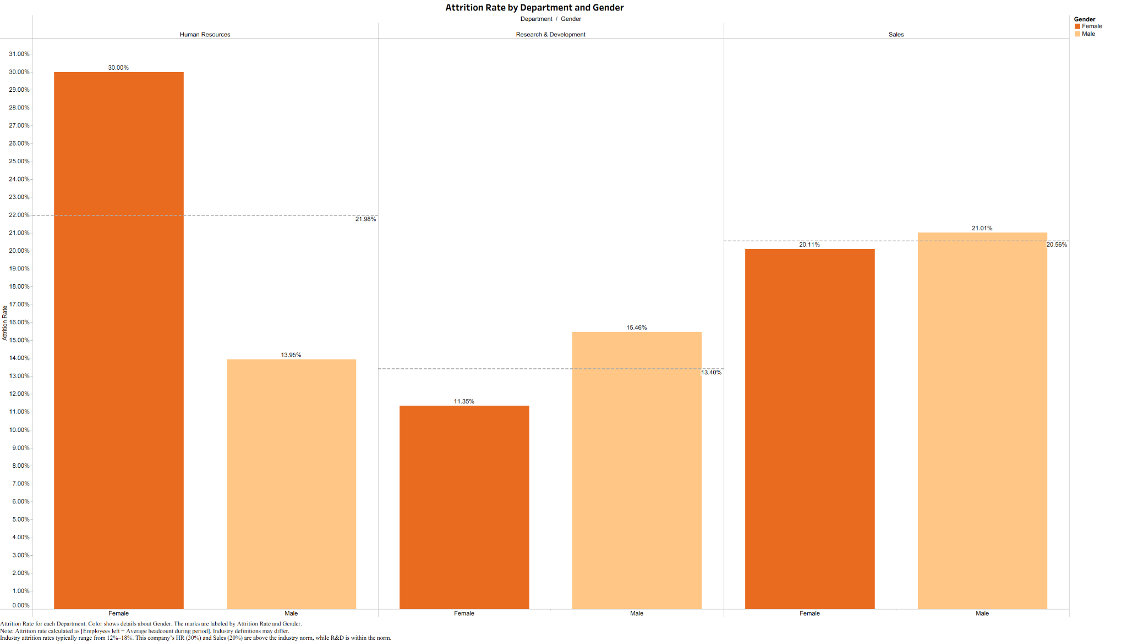

**Fig. 6**

* **Analysis:** How do personal demographic factors (specifically Age and Marital Status) compound the risk for employees in entry-level positions? We sought to determine if the "Job Level 1" attrition crisis is driven by a specific demographic profile.
* **Key Finding:** The highest risk profile is the "Entry-Level Crisis" (Job Level 1), particularly compounded by employees who are Single and under 25 years old.

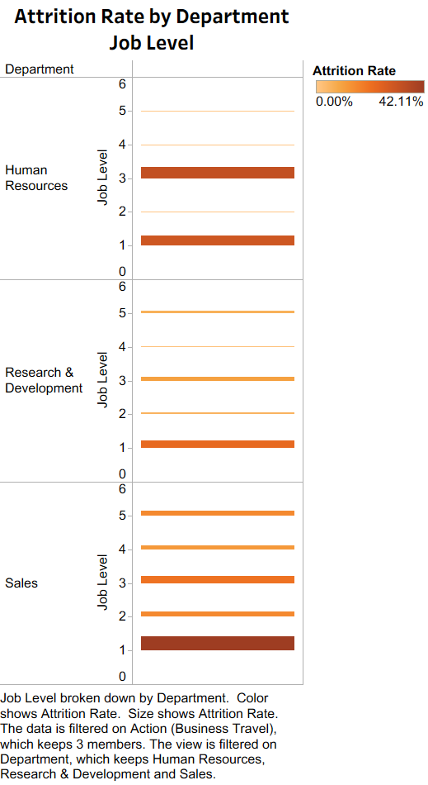

**Fig. 7**

* **Analysis:** To what extent do external stressors, specifically commute distance and business travel frequency, correlate with higher turnover rates? We analyzed the data to identify the "tipping point" where travel burden degrades retention.
* **Key Finding:** "Frequent Travelers" leave at a rate of 24.9%, and attrition rates spike significantly once commute distances enter the "Long" to "Very Long" categories.

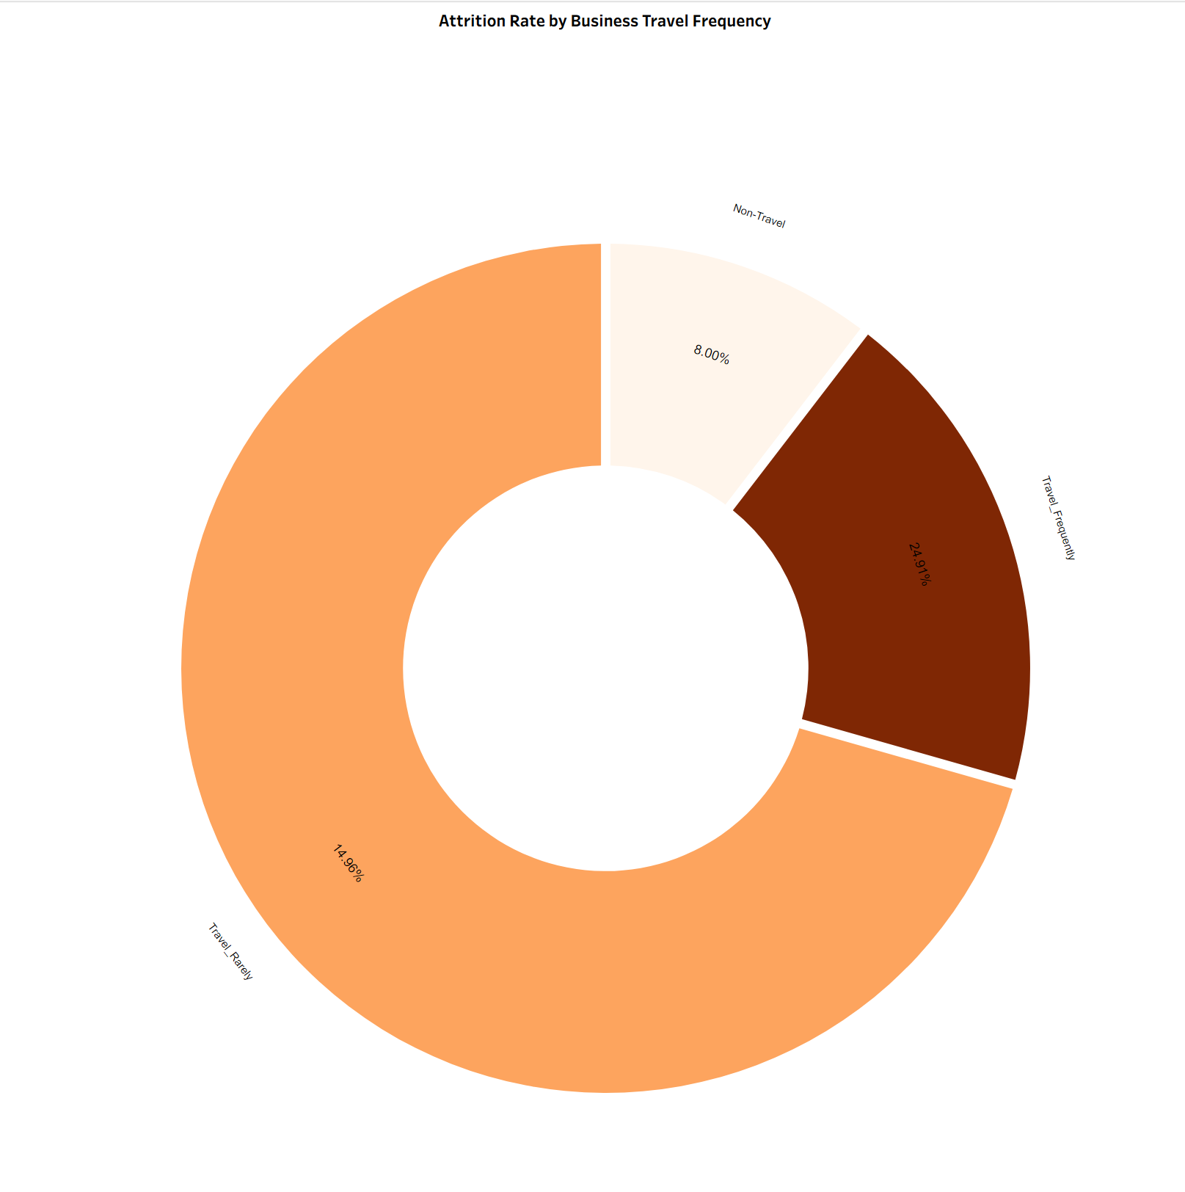

**Fig. 8**

*The donut chart illustrating that Frequent Travelers are 3x more likely to leave than Non-Travelers.*

***Question 5: How does Distance From Home correlate with the likelihood of attrition?***

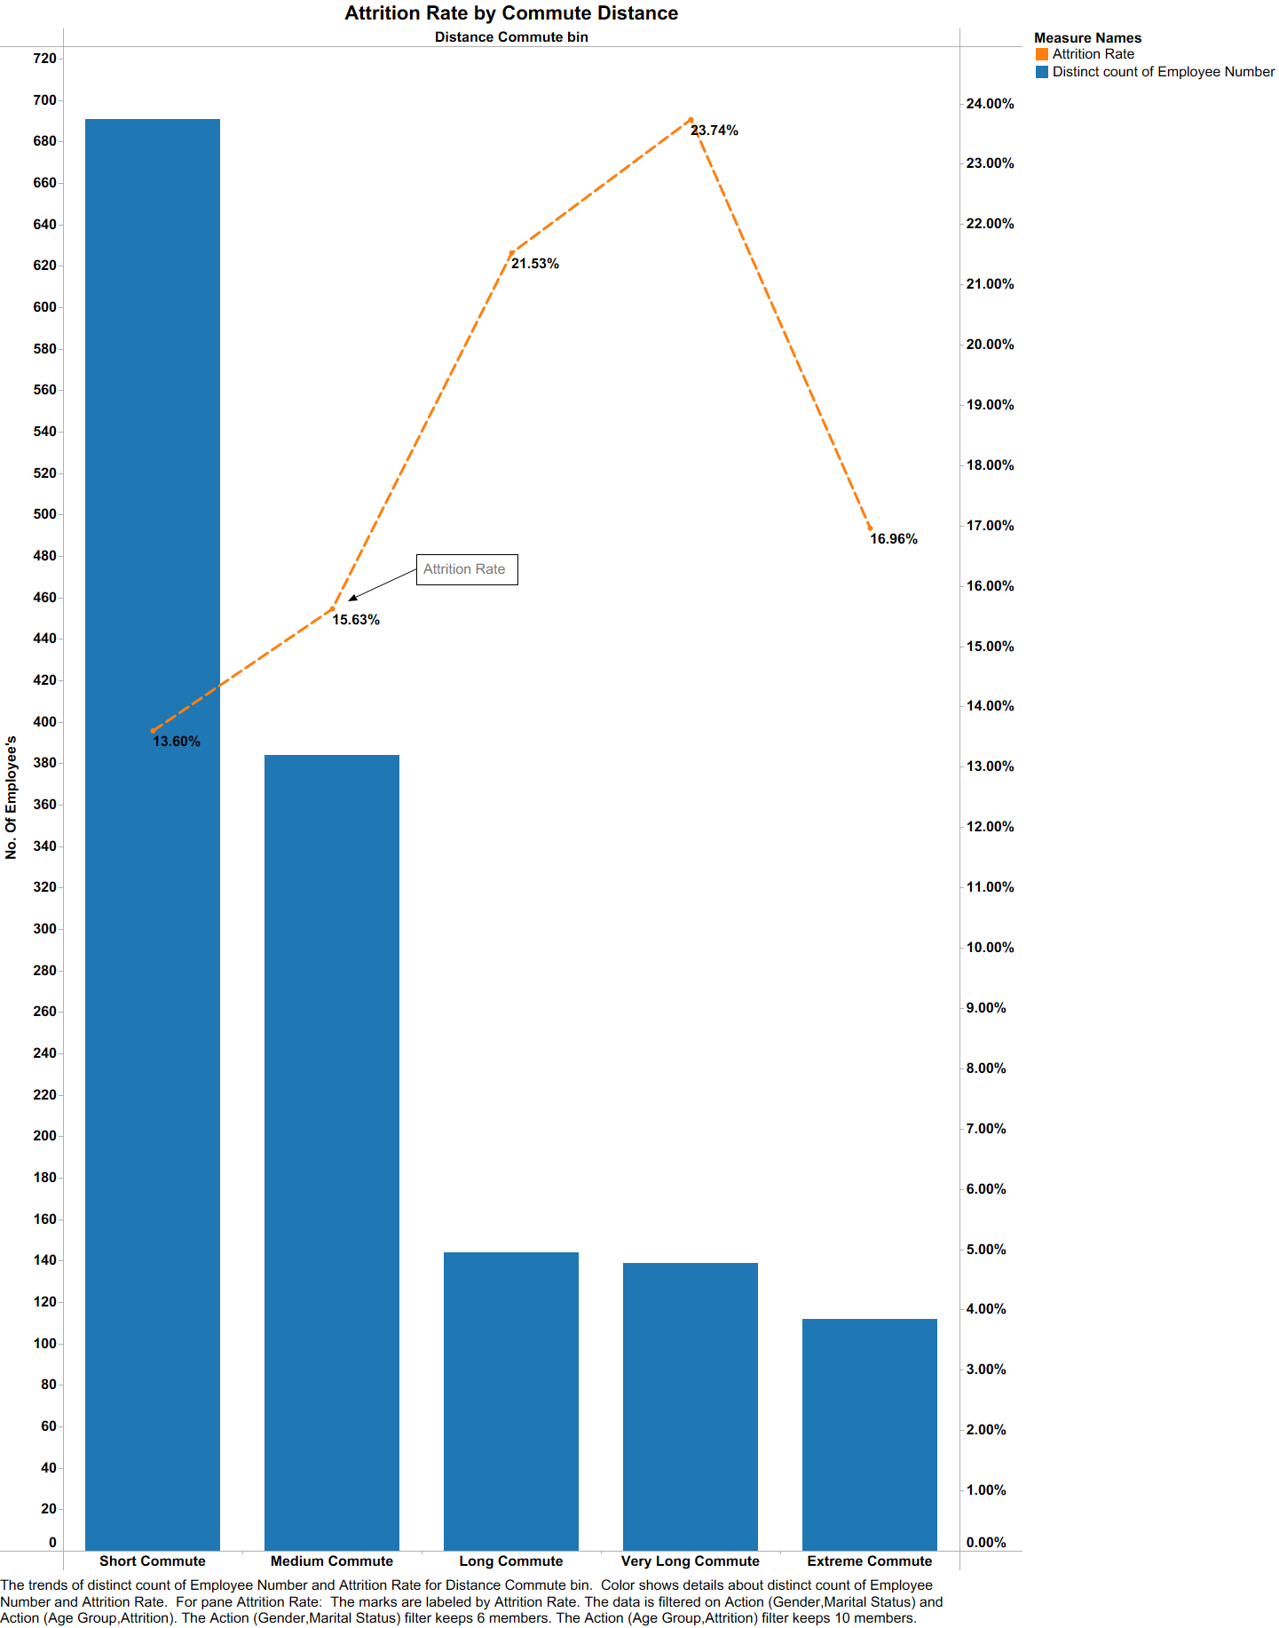

**Fig. 9**

*Attrition Rate vs. Commute Distance, showing a clear correlation between distance and turnover risk.*

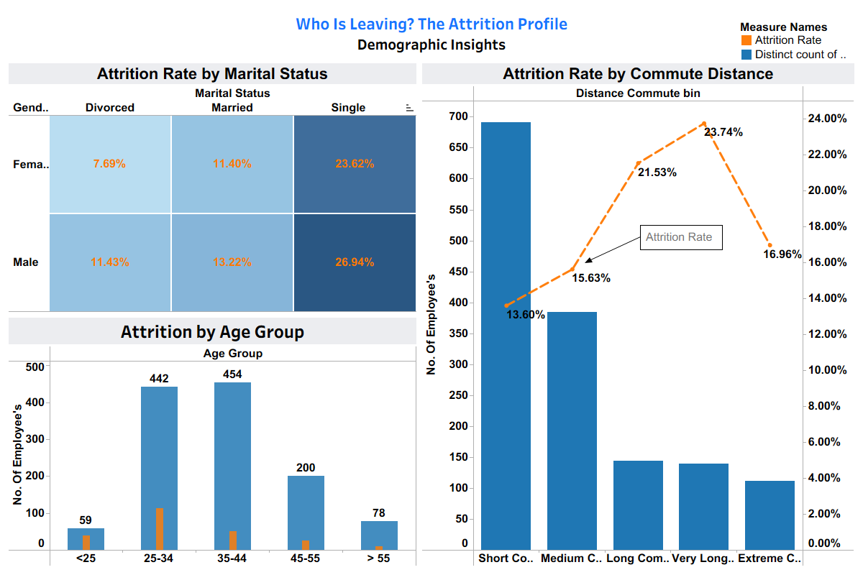 **Fig. 10**

*Demographic Dashboard highlighting the 'Under 25' and 'Single' employee segments as the highest risk categories.*

**Evolution based on Feedback:**

We initially displayed this using a Stacked Bar Chart with a reference band labeled "Industry Average." Feedback highlighted two critical flaws:

1. **Misleading Visualization:** Stacked bars made it difficult to compare the "Male" vs. "Female" values directly. We shifted to a Side-by-Side comparison to decouple the groups.
2. **Incorrect Benchmarking:** The reference line we used was actually an average of our own three departments, not a true "Industry Average," which was misleading. We removed this confusing metric to focus on comparing internal departments against each other.
3. **Aggregation Error:** Feedback noted we were using SUM([Employee Number]) as an axis in early drafts. We corrected this to COUNTD([Employee Number]) to ensure we were counting actual people, not summing their ID codes.

Final dashboards after the analysis and feedback:



**Fig. 11**

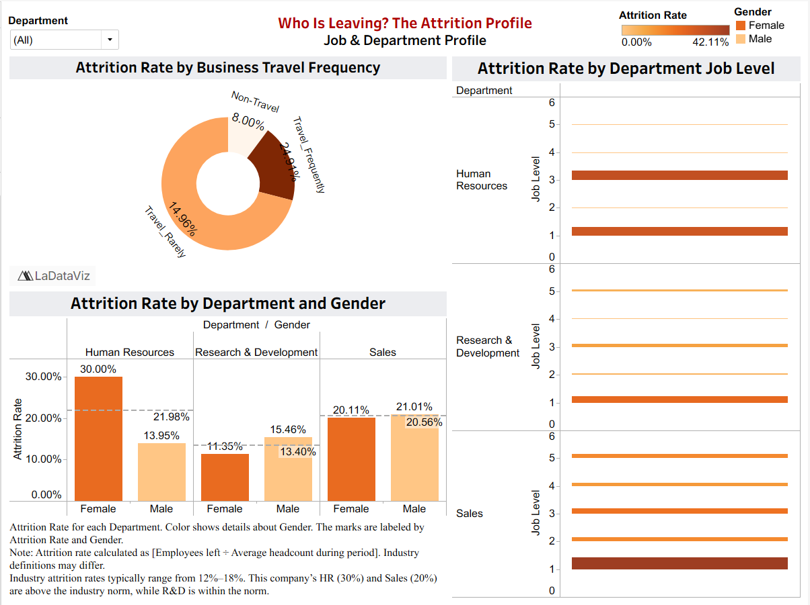

**Fig. 12**

**Page 3 (Theme 3): Root Cause Analysis (Why are they leaving?)**

*Initial Question:* Is salary important?

*Refined Question:* How do Monthly Income distributions, Stock Option tiers, and Salary hikes differ between retained and attrited employees?

**Primary Business Objective**

The primary business objective of this analysis is to identify whether compensation affects employees’ choice to leave the company, and which compensation factors matter the most – monthly income, salary hikes, stock option levels. Understanding these factors allows the company to recognize attrition patterns and develop retention strategies for them.

**Evolution of Analysis & Feedback Integration**

**Visual Clarity:**I received feedback on issues with colors blending, label visibility and unclear distinctions. I revised the labels to illustrate cleaner colors, rotated labels and added outlines to my histogram, making them easier to interpret at a first glance.

**Analytical Accuracy:** I added average attrition lines as reference for Visual 3 and Visual 4, based on feedback received. This helps the viewer have a reference point to compare attrition rates to, making for clearer comparisons.

**Enhanced Cohesion:** I adopted a singular color palette, which helped tie the different charts together and gave a more professional, clean look.

**Refined Analysis Questions & Supporting Visualizations**

***Question 11: How does Monthly Income for employees who leave compare to those who stay?***

* **Analysis:** The chart compares incomes between retained and retired employees and highlights the differences in median pay, spread, and overall compensation.
* **Key finding:** Compensation was found to be a contributing factor in attrition, with employees who leave more concentrated in lower income bands. Employees who stay have a higher median income and wider income range.

**Fig. 13**

***Question 12: Does a lower Percent Salary Hike correspond to a higher probability of attrition?***

* **Analysis:** The chart shows that attrition is high at low salary hikes, with a 10% hike having a 19.5% turnover rate, which is above the average. The trend dips at mid-range hikes and rises again at high-level hikes.
* **Key finding:** Small hike raises make employees more likely to leave. However, a 22% salary hike has the highest attrition rate, suggesting large raises are reactive measures to retain employees already at the risk of leaving.

**Fig. 14**

***Question 13: Does a higher Stock Option Level correlate with lower attrition?***

* **Analysis:** The chart shows that attrition is highest at 24% for employees with no stock options. It then drops for Levels 1 and 2, and rises again for Level 3 at around 18%.
* **Key finding:** Higher stock option levels generally correlate with lower attrition, but the increase at Level 3 shows that stock options alone cannot retain employees with higher risk of attrition.

**Fig. 15**

Final dashboard after the analysis and feedback:

**Fig. 16**

**Page 3 (Theme 4): The Employee Journey (When do they leave?)**

*Initial Question*: When do employees decide to quit?

*Refined Question:* How do Work-Life Balance, Overall Satisfaction levels, and Performance Ratings differ between retained and attired employees, and what do these differences reflect when disengagement begins*?*

**Primary Business Objective**

The primary objective of this analysis is to identify the engagement that exceeds employee turnover. It evaluates Work–Life Balance, Overall Satisfaction, and Performance Rating to understand when disengagement occurs among employees. Comparing retained and attrited employees highlights where employees begin to disconnect from their roles, enabling HR to intervene and prevent voluntary exit.

**Evolution of Analysis & Feedback Integration**

**Chart Purpose:** The feedback pointed out that the original Performance Rating chart looked incorrect because Ratings 3 and 4 showed almost identical attrition rates. These were then confirmed to be the only ratings in the dataset, and the visual was rebuilt to clearly show that the performance rating does not meaningfully impact attrition and hence is not an important factor

**Visual Simplification:** The Overall satisfaction level chart used a vertical bar layout with a misleading reference line, which was the wrong average due to equal weighting. This was later changed into a horizontal bar with employee counts.

**Risk Highlighting:** To make the satisfaction insights more actionable, I added a “High Risk” field to flag satisfaction categories with elevated attrition, allowing to reflect risk.

**Refined Analysis Questions & Supporting Visualizations**

***Question 16: How do Satisfaction Ratings differ between employees who stay and those who leave?***

* **Analysis:** Do different satisfaction ratings show which employees are at higher risk of leaving? This chart compares each satisfaction level and makes it clear that attrition is highest at the lowest satisfaction scores. It helps us see exactly where disengagement begins, so leaders know which groups need support the most.
* **Key finding:** Attrited employees score lower than retained employees for all four satisfaction metrics. In every parameter, the orange bar (“Yes”) remains below the blue bar (“No”), where both groups fall below the healthy satisfaction threshold of 3.0. The gap is evident for Job Satisfaction and Environment Satisfaction, where attrited employees drop into the mid-2.4 range, indicating that dissatisfaction shows early in an employee's career journey and is a strong indicator for the future**.**

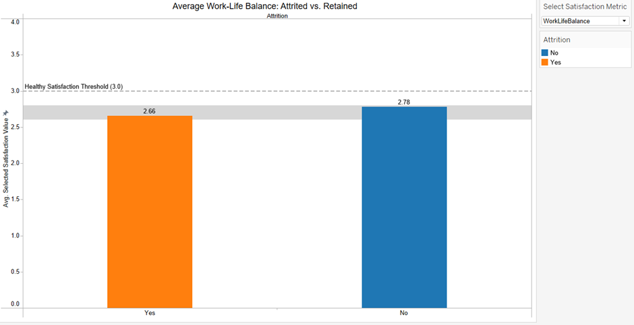

**Fig. 17**

***Question 17: Is a low combined satisfaction score a strong indicator of potential attrition?***

* **Analysis:**Does overall satisfaction predict which employees are at higher risk of leaving? This chart compares satisfaction levels and shows where attrition is at the lowest satisfaction levels, which helps leaders identify morale issues and create employee satisfaction programs before they decide to leave.
* **Key finding:** Employees in the lowest satisfaction tiers show the highest attrition risk, with Level 1 exceeding 50% turnover. Attrition drops as satisfaction levels are high, showing that overall satisfaction is a strong predictor of whether an employee will leave.

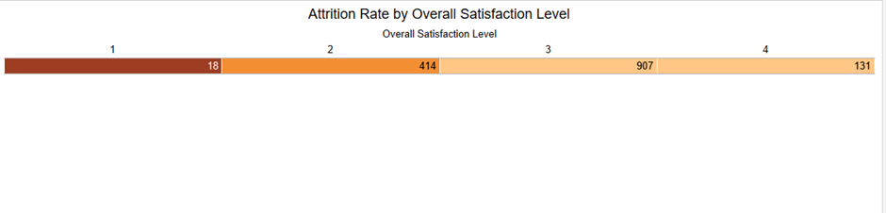**Fig. 18**

***Question 18: Is there a connection between an employee's Performance Rating and their decision to leave?***

* **Analysis:** High performers leaving the organization is expensive and damaging, and exploring if performance rating influences attrition helps determine top performers are disengaged, or at risk, and require strategies of recognition, reward, and career development.
* **Key finding:** High performers with Ratings 3 and 4 leave at almost the same rate (16.37% vs 16.08%). Confirming that performance rating is not a strong predictor of attrition in this dataset.

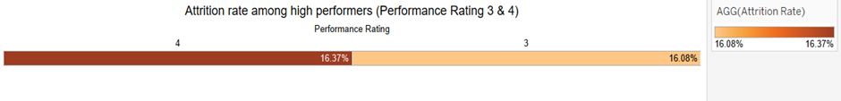**Fig. 19**

Final dashboard after the analysis and feedback:

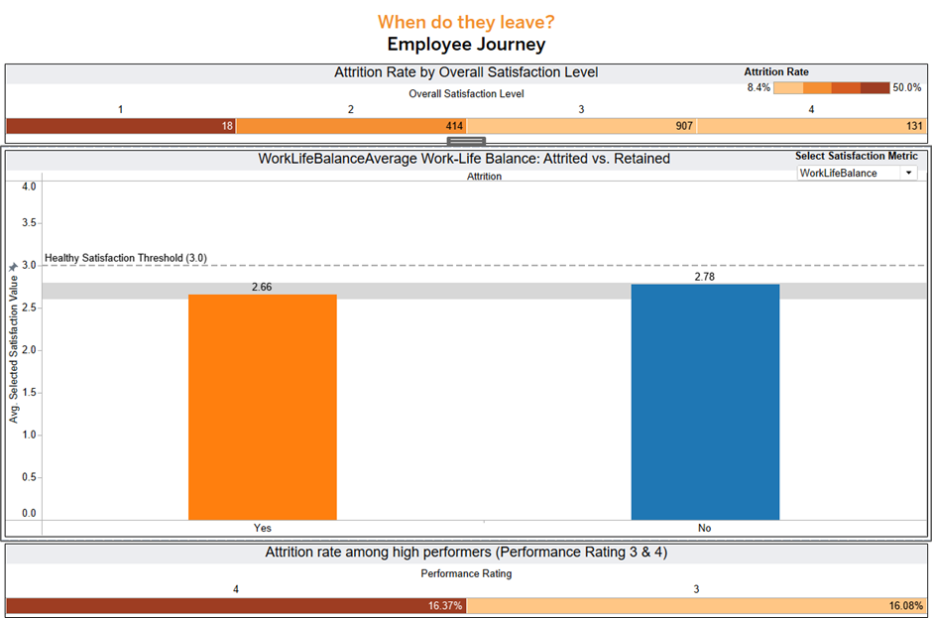 **Fig. 20**

**Page 4: The Employee Journey (When do they leave?)**

**Attrition Rate by Employee Tenure**

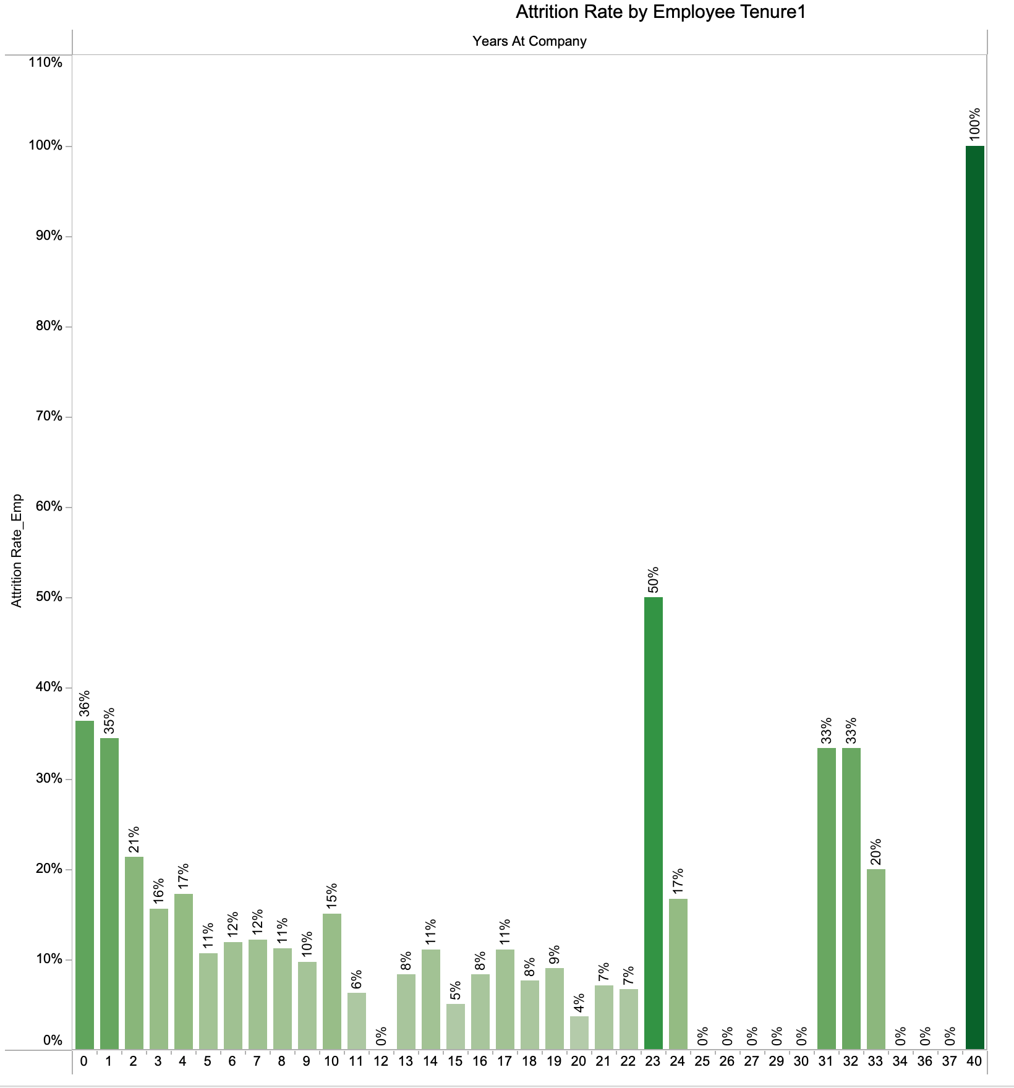

**Fig. 21**

***Question 18: At what point in an employee's tenure (Years at Company) is attrition most likely to occur?***

* **Analysis:**Visual evidence here speaks loudest: employees with shorter tenure are significantly more likely to quit. Those in their first year at the company show the highest likelihood of attrition, far exceeding the rates seen among mid- and long-tenured employees. As tenure increases, attrition rates decline steadily, reflecting a period of adjustment after which employees tend to become more stable and committed.
* **Key finding:** First-year employees are one to three times more likely to quit than employees with longer tenure. Attrition drops gradually as employees gain experience and integrate into the organization. The trend highlights the need for stronger onboarding, early engagement, and career support during the initial years of employment.

**Attrition Rate by Years Since Last Promotion** 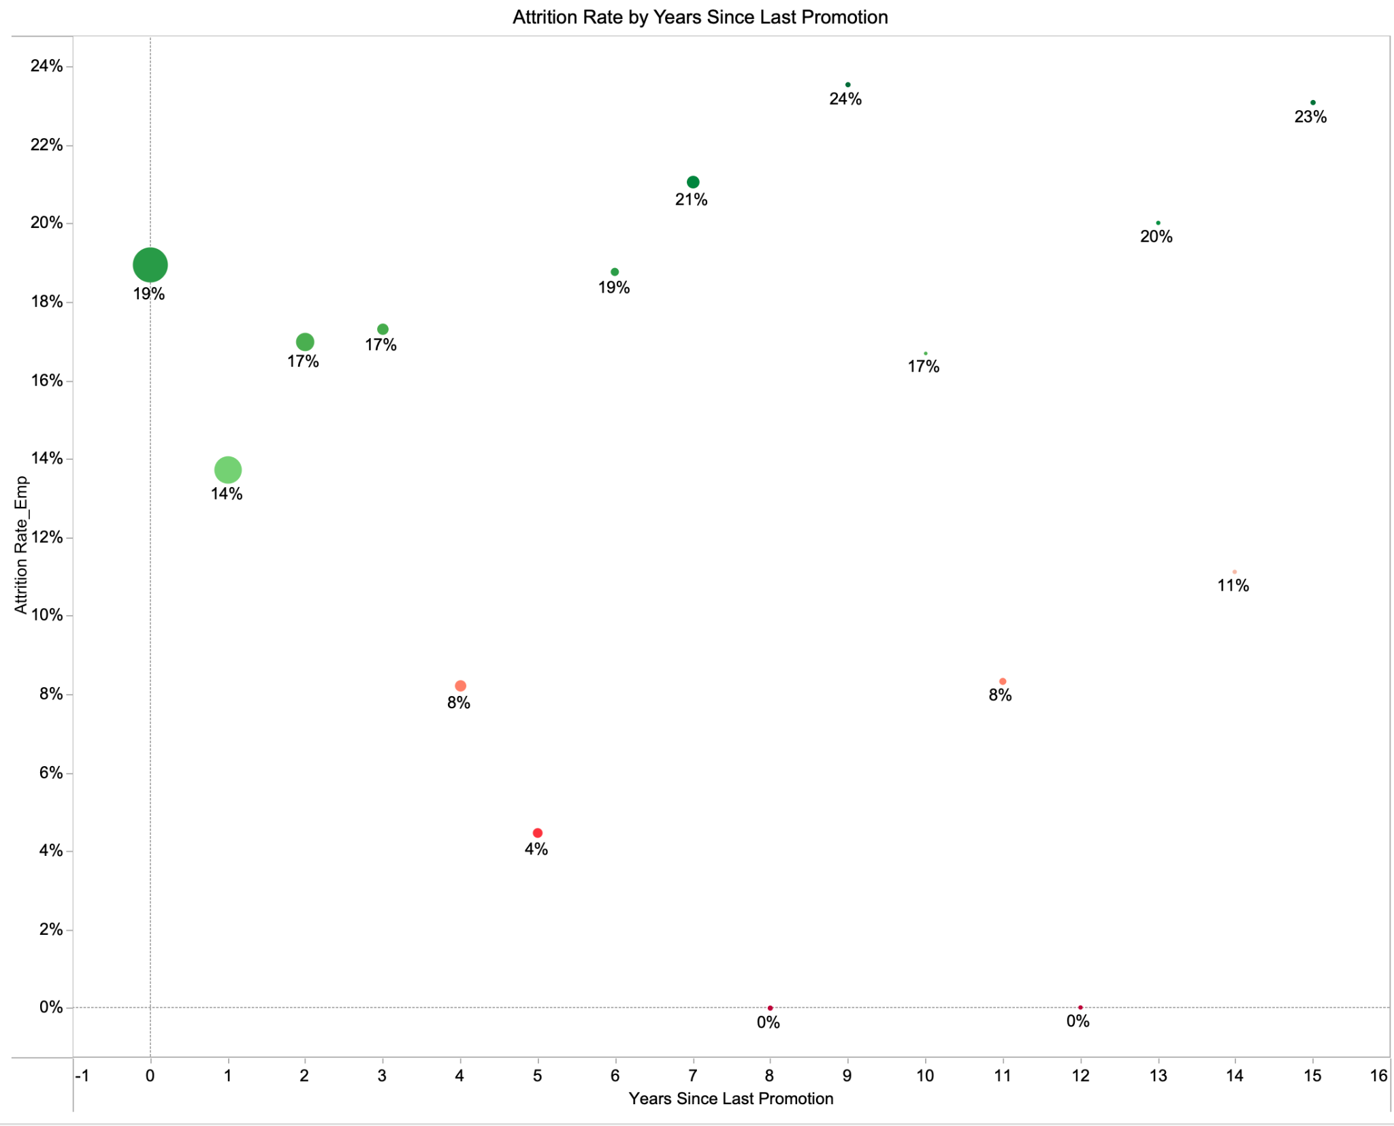

**Fig. 22**

***Question 19: How does the time Years Since Last Promotion affect attrition rates?***

* **Analysis:**The graph shows that employees become increasingly likely to quit the longer they go without a promotion, with attrition peaking between four and seven years since their last advancement. This indicates that career stagnation during this period is a major driver of turnover, while employees who receive timely promotions are less likely to leave.
* **Key finding:** Employees are most likely to quit 4–7 years after their last promotion, making lack of advancement a key factor in turnover. Fast-track or regular promotions reduce attrition, highlighting the need for clear development plans and transparent progression opportunities.

**Attrition Rate by Number of Previous Companies**

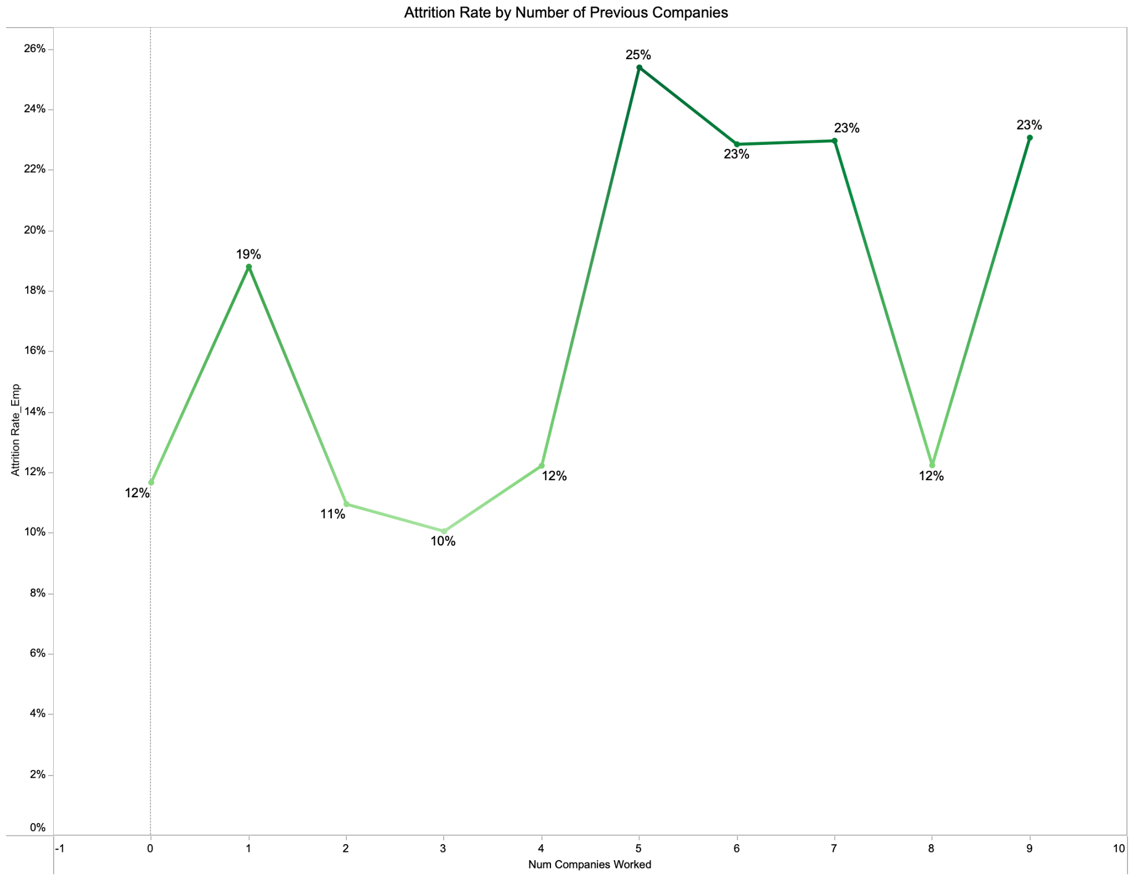

**Fig. 23**

***Question 20: Do employees who have worked at more companies previously… have a higher attrition rate?***

* **Analysis:**The graph examines attrition in relation to employees’ previous work history and shows that those with a higher number of prior employers—particularly five or more—exhibit significantly higher attrition rates. This suggests a clear mobility pattern, where frequent job changers are more prone to leave, while employees with fewer past employers tend to remain more stable.
* **Key finding:** Employees with five or more previous companies are the most likely to quit, indicating a strong link between extensive job-hopping history and attrition. Understanding these mobility patterns can help HR tailor retention strategies toward employees who are more likely to change jobs.

Final dashboard after the analysis and feedback:

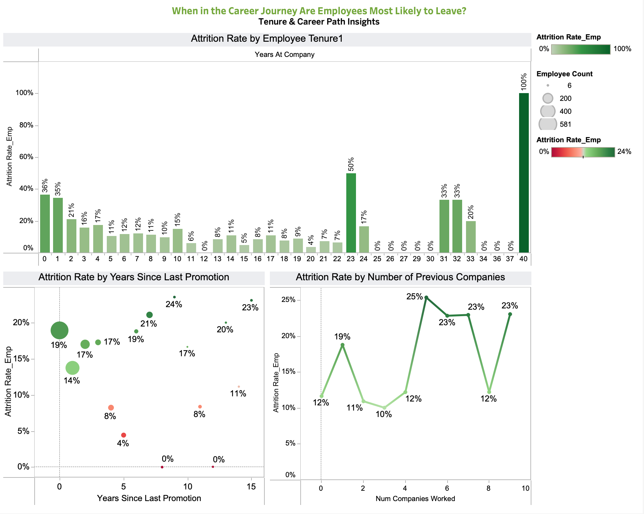

**Fig. 24**

**Data & Preparation**

**Dataset Provenance:** We utilized the IBM HR Analytics Employee Attrition & Performance dataset sourced from Kaggle (Rishikesh Konapure). It contains 1,470 records and 35 distinct variables.

**Data Preparation & Value-Added Cleaning:** Since Assignment 1, we performed significant data engineering to support our specific visualizations:

1. **Quantifying Attrition:** Created an Attrition Numeric calculated field (Yes=1, No=0) to facilitate rate calculations.
2. **Binning for Clarity:** Created bins for continuous variables to reveal trends that scatter plots missed:

* Age Groups (e.g., 25-34).
* Tenure Bins (0-2 years, 3-5 years).
* Distance Bins (Short, Medium, Long Commute).
* Income Bins (<$3k, $3k-$5k).

1. **Weighted Averages:** Based on feedback regarding misleading reference lines, we created Level of Detail (LOD) expressions to calculate *Weighted Average Attrition Rates* per department, rather than simple averages of percentages.
2. **Satisfaction Scoring:** Created a combined Overall Satisfaction metric by averaging Job, Environment, and Relationship satisfaction scores.
3. **Calculated Fields:**

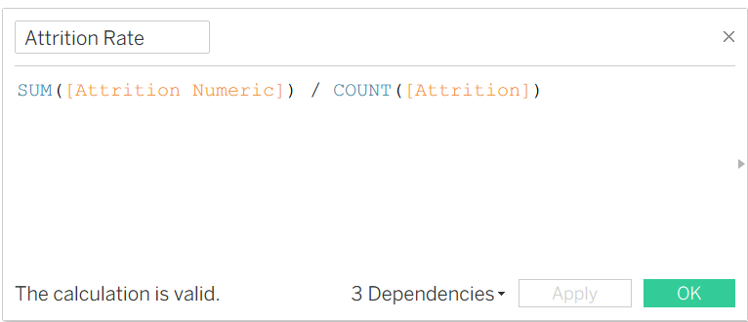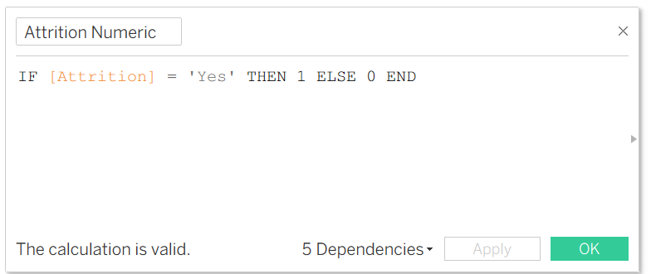

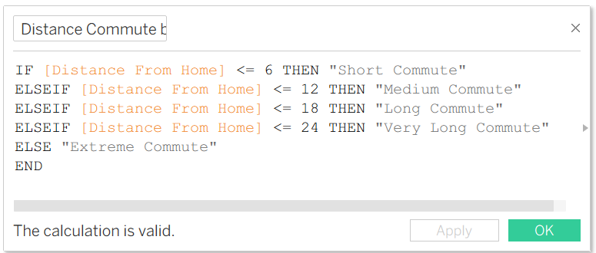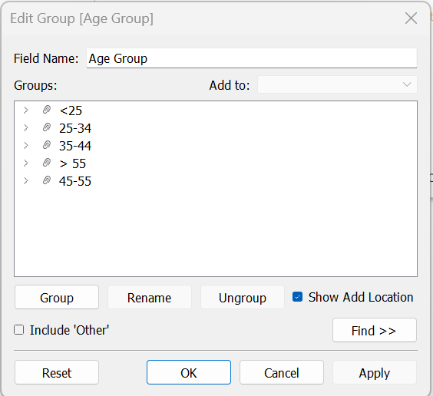

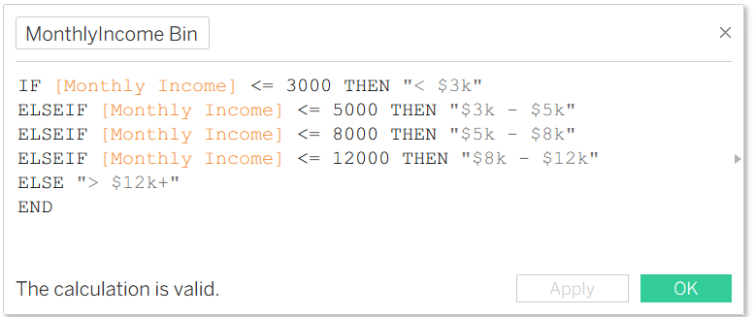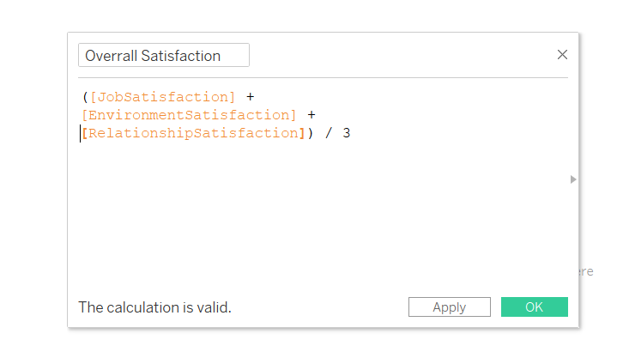

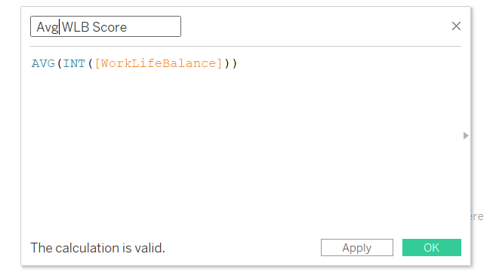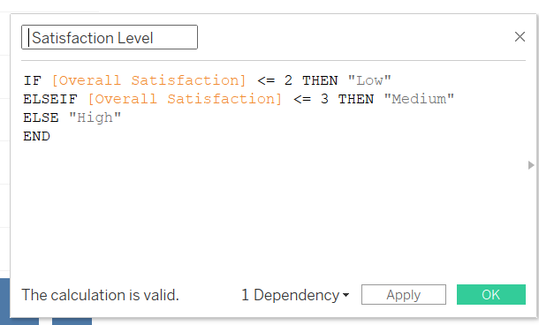

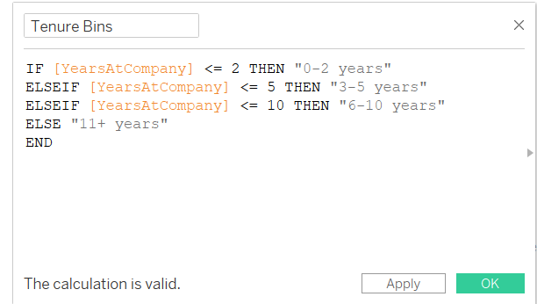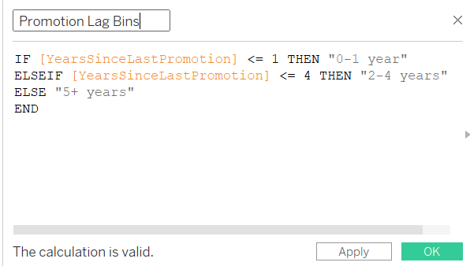

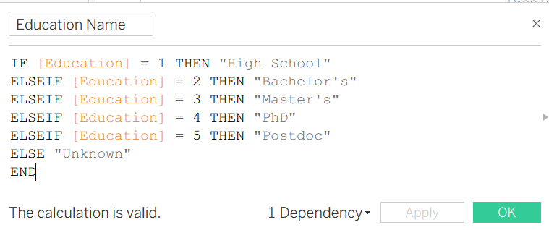

**Fig. 25**

**Visualizations & Design Rationale**

Our analysis is presented through a four-page Tableau Story, designed to guide the user from a high-level overview down to specific, actionable root causes. We adhered to a "Martini Glass" narrative structure, beginning with a broad overview (the wide top) and narrowing down to specific driver analysis (the stem).

**Page 1: Overview: The Big Picture**

**A. Logical Arc & Objectives**

This dashboard highlighted broad organizational drivers such as overtime, job role, and satisfaction, that applies lens to examine how different groups experience those drivers differently.

* Employees with similar job roles may not have the same risk level.
* Demographic factors such as age or marital status may amplify or reduce risk.
* Department-level culture, workload, and expectations may contribute to unequal attrition patterns.

This connection is important because it allows us to move from general insights (“overtime leads to higher attrition”) to specific, actionable risk profiles (“young, single employees working in Sales and traveling frequently are most likely to leave”).

**B. Key Visuals & Feedback-Driven Iteration**

**Key Visual 1: Attrition Rate by Overtime (Bar Chart)**

* Source Question: Are employees who work Overtime significantly more likely to leave?
* Insight: Overtime is a primary systemic driver. Employees who work overtime have a drastically higher attrition rate, pointing directly to burnout, unsustainable workloads, or poor work-life balance as a root cause.
* Design Principle (Direct Comparison): A simple, clean bar chart places the "Yes" and "No" categories side-by-side. The dramatic difference in bar height makes the severe risk associated with overtime immediately and unambiguously clear, requiring no complex interpretation.

**Key Visual 2: Attrition Rate by Job Role (Sorted Bar Chart)**

* Source Question: Which Job Roles have the highest and lowest attrition rates?
* Insight: Attrition risk is highly concentrated in specific functions. Sales Representatives and Laboratory Technicians show critically high rates, indicating role-specific issues such as high stress, unclear career paths, or compensation models that are not working.
* Design Choice: A sorted bar chart allows for easy, ranked comparison across all roles. The viewer's eye is instantly drawn to the longest bars on the top (the highest-risk roles), enabling rapid prioritization of which departments require immediate intervention.

**Key Visual 3: Attrition Rate by Job Satisfaction (Lollipop or Bar Chart)**

* Source Question: What is the impact of Job Satisfaction on attrition?
* Insight: Job Satisfaction is the strongest predictive factor. Dissatisfied employees leave at more than double the rate of satisfied ones. This shifts the narrative from external factors to the core emotional and psychological experience of work.
* Design Principle (Emphasizing Extremes): A bar chart effectively highlights the extreme ends of the scale. The vast gap between the "Low" and "High" satisfaction categories visually underscores that improving the employee experience is not a peripheral HR activity, but a central business imperative for retention.

**Before:**

**Fig. 26**

**After**:

**Fig. 27**

**Top:** Attrition Rate by Job Role – highlights which job roles have the highest turnover rates.  
**Bottom Right:** Attrition Rate by Overtime – compares attrition between employees working overtime vs. not working overtime.   
**Bottom Left:** Attrition Rate by Job Satisfaction – shows that lower satisfaction levels correspond to higher attrition.

**Page 2: The Attrition Profile (Who is leaving?)**

This dashboard, titled "Who Is Leaving? The Attrition Profile," serves as the second chapter of our analysis, drilling down from high-level trends to specific, actionable segments.

**A. Logical Arc & Objectives**

**Objective:** To identify high-risk employee segments by analyzing demographic factors (Age, Marital Status, Commute) alongside structural factors (Department, Gender, Job Role). **Logical Flow:** The narrative progresses from broad personal factors (Page 1) to specific organizational friction points (Page 2).

* **Theme 1 (Demographics):** Focuses on *who* the employee is outside of work (Age, Marital Status, Commute Distance).
* **Theme 2 (Job Profile):** Focuses on *where* the employee sits within the company (Department, Travel Requirements, Job Level).

**B. Key Visuals & Feedback-Driven Iteration**

**Theme 1: Demographic Insights**

**Key Visual 1: Attrition Rate by Commute Distance (Dual-Axis Chart)**

* **Insight:** Long commutes are a significant retention risk. The attrition rate climbs steadily as commute distance increases, peaking at ~24% for "Very Long Commutes."
* **Design Choice:** A dual-axis chart combines the volume of employees (Bar) with the attrition rate (Line). This reveals that while the largest group of employees has short commutes (low risk), a significant minority faces long commutes with much higher risk.

**Key Visual 2: Attrition Rate by Marital Status (Heatmap)**

* **Insight:** Single employees have the highest attrition rate across genders, particularly Single Males (26.94%).
* **Design Principle (Pretensive Attributes):** We used color intensity to encode attrition rate. Darker blue immediately draws the eye to the "Single" column, making the high-risk segment instantly recognizable without needing to read every number.

**Before:**

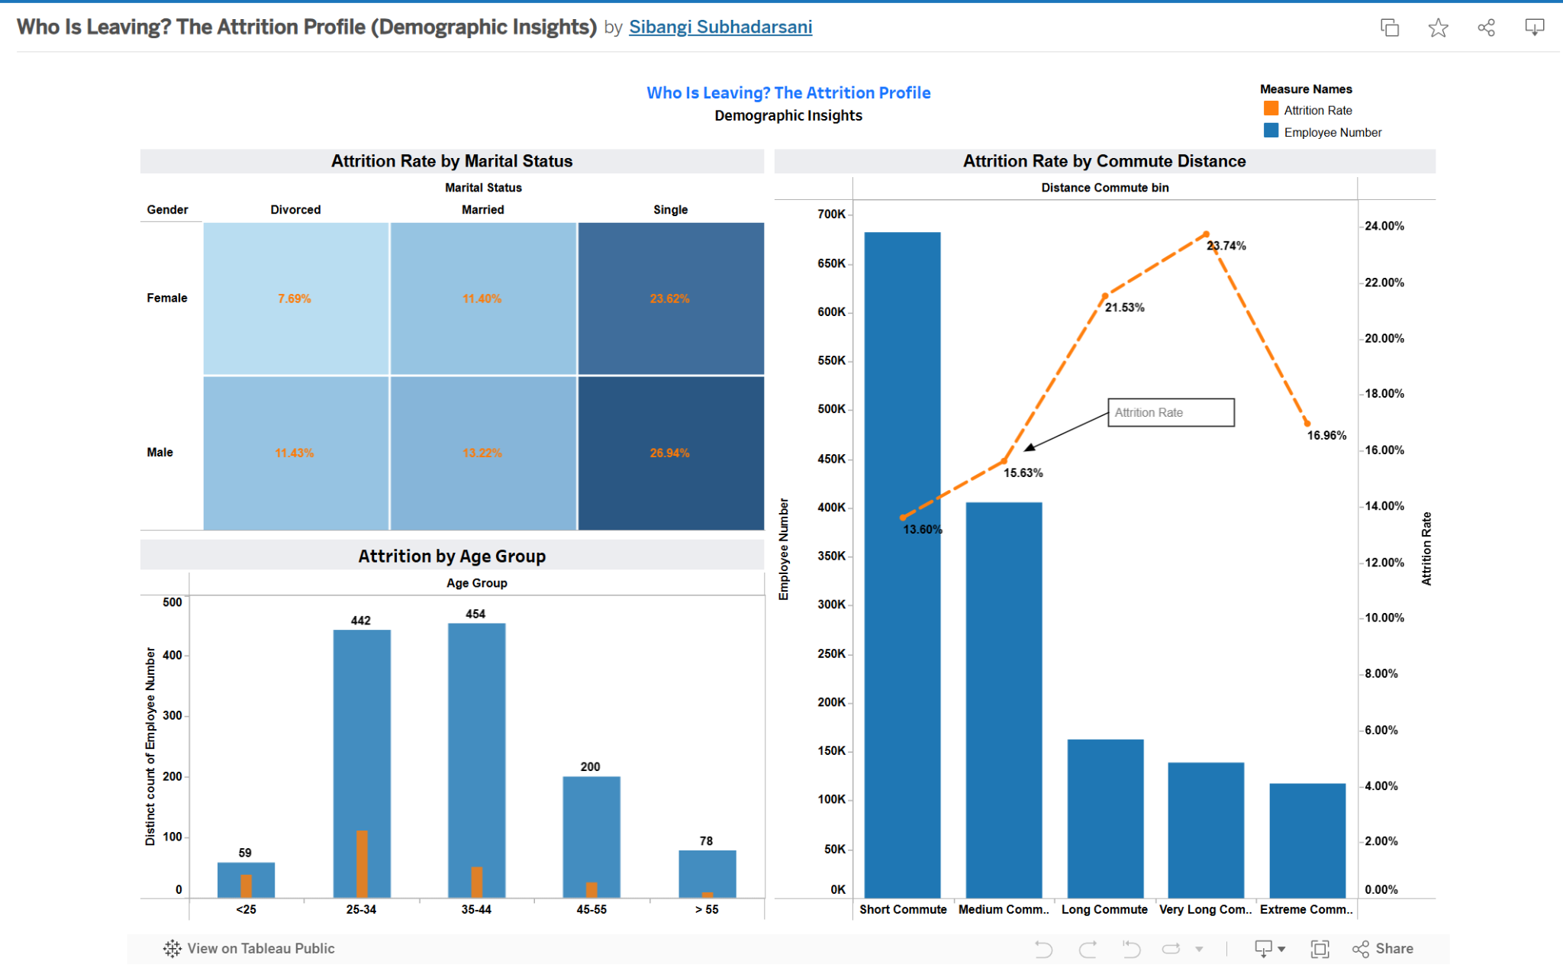

**Fig. 28**

**After:**

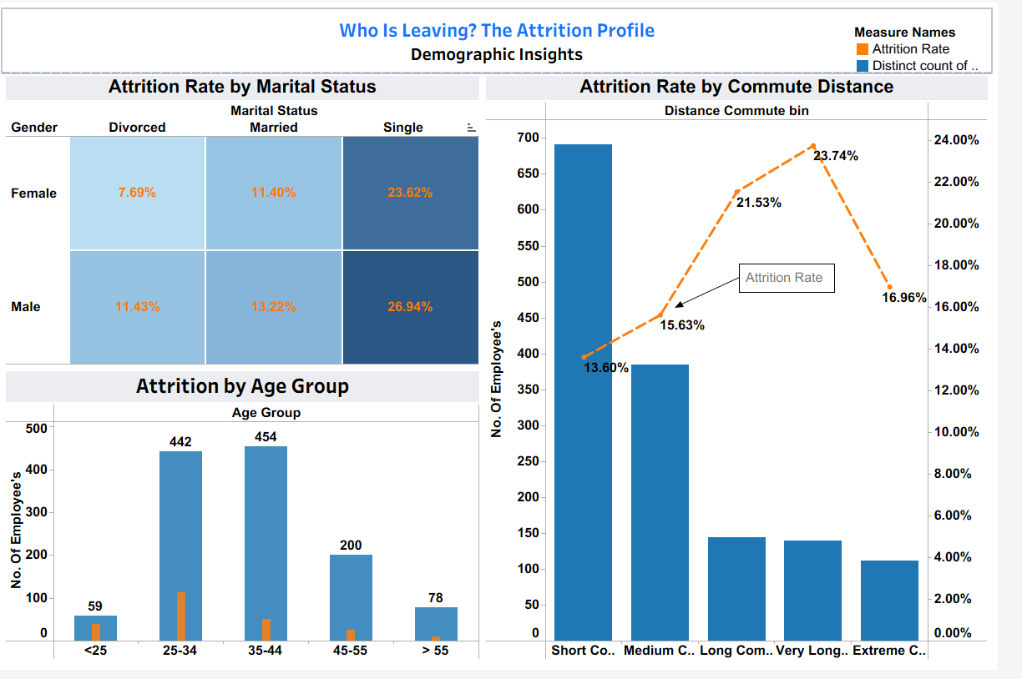

**Fig. 29**

**Top Left:** Attrition Rate by Marital Status & Gender (identifying high-risk demographics, specifically among single employees).

**Bottom Left:** Attrition by Age Group (analyzing workforce distribution and turnover volume across generational cohorts).

**Right:** Attrition Rate by Commute Distance (correlating commute length with retention risk using a dual-axis view).

**Theme 2: Job & Department Profile**

**Key Visual 3: Attrition Rate by Business Travel Frequency (Donut Chart)**

* **Insight:** Frequent travel is a major stressor; employees who **"Travel Frequently"** have the highest attrition rate (~24.9%).
* **Transformation (Before/After):**

*Before:* Initially used a "Viz Extension" for the donut chart. Feedback indicated this was problematic: *"Tableau can’t export Viz Extensions,"* rendering the chart invisible to many viewers. Tooltips also displayed inconsistent proportions.

*After:* Used a "Viz Extension" as I was interested in using the donut chart and ensured 100% visibility, accurate tooltips, and clear labeling.

**Key Visual 4: Attrition Rate by Department and Gender (Side-by-Side Bar)**

* **Insight:** HR shows a critical gender disparity, with female attrition (30.0%) being double that of males.
* **Transformation (Before/After):**

*Before:* Used a **Stacked Bar Chart** with a solid reference band labeled "Industry Range." Feedback noted stacked bars obscured direct gender comparison, and the reference line was misleading (it was an internal average, not an industry benchmark).

*After:* We switched to a Side-by-Side Bar Chart to allow for direct, unhindered comparison of gender groups. We removed the misleading reference line entirely to adhere to data integrity standards, focusing instead on the clear internal disparity.

**Key Visual 5: Attrition Rate by Department Job Level (Strip Plot)**

* **Insight:** Isolates attrition hot-spots by seniority. For instance, R&D attrition is concentrated at Level 1 (early career).
* **Correction:** Feedback highlighted an aggregation error where we used SUM([Employee Number]) as an axis. We corrected this to COUNTD([Employee Number]) or the calculated Attrition Rate to ensure the visualization represents actual human capital density.

**Before:**

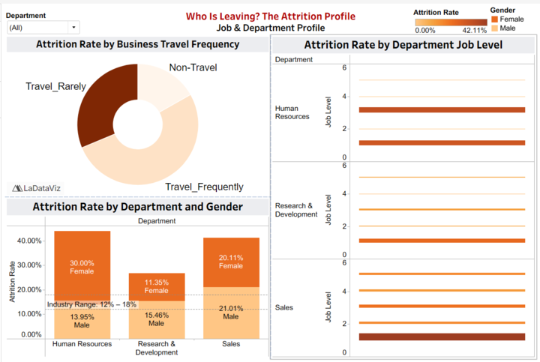

**Fig. 30**

**After:**

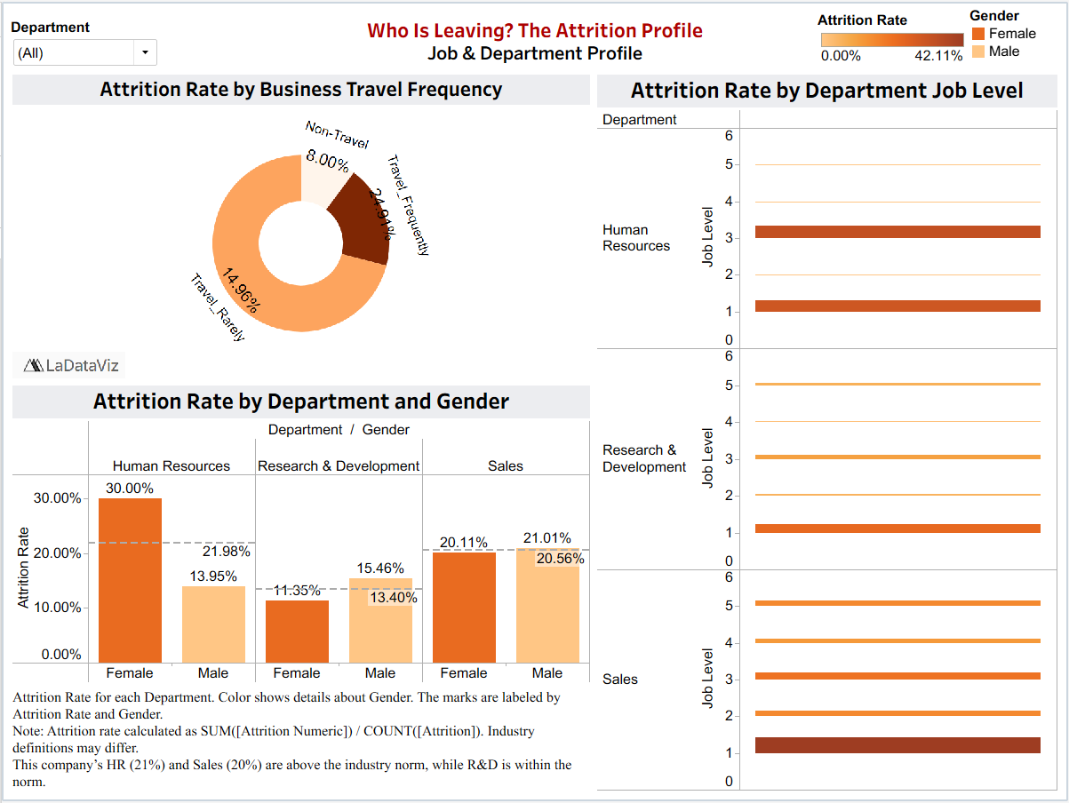

**Fig. 31**

* **Top Left:** Impact of travel frequency (a known stressor).
* **Bottom Left:** Attrition by Department & Gender (checking for disparities).
* **Right:** Specific Job Levels within departments (pinpointing hierarchy-based risk).

**C. Explicit Design Principles Applied**

1. **Tufte’s Graphical Integrity:**

* **Truth in Labeling:** By removing the unverified "Industry Average" reference line, we adhered to Tufte’s principle that graphics must not quote data out of context (Tufte, 2001).
* **Snapshot Context:** Addressing the feedback that *"data represents a single year,"* we moved the total employee count from hidden captions to visible KPI banners. This clarifies that the analysis is a cross-sectional snapshot, preventing users from inferring false historical trends (Tufte, 2001).

1. **Cole Nussbaumer Knaflic’s "Preattentive Attributes" (Color):**

* **Monochromatic Palettes:** We used distinct monochromatic schemes for each theme to aid navigation (Knaflic, 2015).

**Theme 2.1 (Blue):** Dark Blue = High Risk (e.g., Single employees).

**Theme 2.2 (Orange/Brown):** Dark Brown = High Intensity (e.g., Frequent Travel).

* This consistent use of intensity leverages the intuitive "Darker = More" association, allowing stakeholders to scan dashboards and instantly spot high-risk segments (Knaflic, 2015).

1. **Gestalt Principle of Proximity:**

* Charts are grouped by semantic category. In Theme 1, "Personal Demographics" (Age, Marital Status) are clustered together, distinct from "Commute." In Theme 2, "Departmental Structure" charts are grouped separately from "Job Level" detail. This spatial organization reduces cognitive load by creating clear analytical "zones" for the user (Knaflic, 2015).

**Theme 3: Root Cause Analysis (Why are they leaving?)**

1. **Objective and flow**

**Objective:** To identify the root cause of employee attrition, focusing on income distribution, salary hikes, and stock option levels.

**Logical Flow:** The visualization follows a top-down approach. It starts with highlighting income differences between attrited and retained employees, before moving onto distribution level income, and then lastly salary hikes and stock option flow which explains why there is attrition.

1. **Key Visuals & Feedback**

**Before:**

**Fig. 32**

**After:**

**Fig. 33**

**Top Left:** Monthly Income Distribution (visualized between attrited and retained employees)

**Top Right:** Income Distribution Histogram (visualized between attrited and retained employees)

**Bottom Left:** Attrition Rate By Percent Salary Hike (among only attrited employees)

**Bottom Right:** Attrition Rate By Stock Option Level (among only attrited employees)

***Visual 1:*** Monthly Income Distribution

**Insight:** Employees leaving the company are mostly on the lower-income range with a lower median and narrow income distribution. It highlights that compensation is a big driver of attrition.

Transformation:

* **Before:** The visual had a purple title bar and lower opacity, make income groups harder to distinguish.
* **After:** The revised visual has cleaner colors with clearer shading in the boxplot, making the income differences stand out.

***Visual 2:*** Income Distribution Histogram

**Insight:** Employees leaving the company are heavily concentrated in lower income bins, particularly between $1K and $4K. Attrition rates start dropping with the increase in income, reaffirming that compensation is an important factor.

Transformation:

* **Before:** The visual had vertical bars with labels on the x-axis not clearly visible.
* **After:** The revised visual has horizontal bars, bar outlines, and clearly visible labels making it easier to interpret.

***Visual 3:*** Attrition Rate By Percent Salary Hike

**Insight:** Employees with small salary hikes have high attrition rates. What’s interesting is that attrition rises again with high salary hikes as well. This might be reactive salary hikes for employees already planning to leave the company.

Transformation:

* **Before:** The visual didn’t have a reference point of average attrition.
* **After:** The revised visual has an average attrition line.

***Visual 4:*** Attrition Rate By Percent Salary Hike

**Insight:** Employees that have 0 stock options are mostly to leave the company. Attrition rises again at stock option 3, which could mean it is harder to retain senior employees.

Transformation:

* **Before:** The chart used the same color for all the same options and lacked a reference point.
* **After:** The revised visual uses a gradient color to signal intensity of attrition, while also having an average attrition line.

**C. Design Principles Applied**

* Tufte’s Principle

Visual 1 follows Tufte’s principle of minimizing clutter from the chart by presenting clean and simple box plot.

Visual 4 follows Tufte’s minimalism (Tufte, 1983) by showing how employees’ attrition rate gradually falls as their stock options increase.

* Cole Nussbaumer Knaflic’s Principle

Visual 4 shows how the dots are in a gradient green color which makes the attrition rate differences more clear, following Cole Nussbaumer’s principle of using color with purpose.

**Theme 4: The Employee Journey (When do they leave?)**

**A. Objective and Flow**

**Objectives:** to identify when disengagement occurs among employees analysing satisfaction levels, work - life balance and performance rating.  
**Logical Flow:** The visualisation starts with satisfaction levels which are early signs of development narrowing into specific drivers like WLB, Job satisfaction, Environment Satisfaction, Relationship Satisfaction, and ending it with performance rating comparison confirming if performance predicts retention.

**Before:**

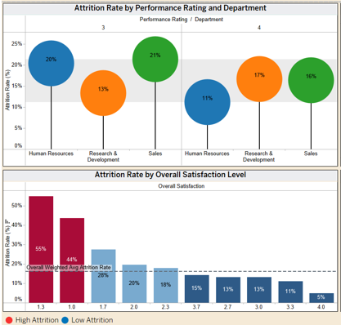

**Fig. 34**

**After:**



**Fig. 35**

* **Top:** Overall satisfaction levels - identifies where attrition is highest among low satisfaction.
* **Middle:** Satisfaction Metrics - parameter view comparing Work-Life, Job, Environment, and Relationship satisfaction for attrited vs retained employees.
* **Bottom:** Performance Rating - confirming rating 3 & 4 have same attrition rates.

**B. Key Visuals & Feedback**  
  
***Visual 1:*** Attrition Rate by Overall Satisfaction Level

**Insight:** Only 18 employees fall into the lower satisfaction tier, yet most of them leave because the attraction rate is 50%. While much larger employees (414 and 907) at scores 2 and 3 show lower attrition (25.8% and 12%) showing us how a small group of unhappy employees can lead to turnover.

Transformation:

* **Before:** A vertical bar chart with a wrong average reference line and performance rating of 16%
* **After:** A horizontal segment bar along with employee counts and calculated field of ‘High Risk’ to highlight low satisfaction scores.

***Visual 2:*** Satisfaction Metrics

**Insight:** employees who leave score lower on every metric and every score is below 3.0. Job satisfaction shows the lowest among all at 2.47 for attrited employees which also is global HR research which identifies that low satisfaction as the number one driver of turnover.

Transformation:

* **Before:** each metric was a chart, making layout inconsistency and understanding of dissatisfaction
* **After:** bar comparison along with parameters and adding a reference line of 3.0 threshold.

***Visual 3:*** Attrition Rate by Performance Rating

**Insight:** Performance rating 3 “Excellent” and 4 "Outstanding" have same attrition rates reflecting it is not a strong factor of turnover.

Transformation:

* **Before:** bubble chart showing department x performance rating, questioned if it was an error since they were identical.
* **After:** simplified side by side bar, with clear attrition percentages and clarified there are only 3 and 4 ratings.

**C. Design Principles Applied**

* Munzer’s Principle
  + Clarity over clutter: reduced information clutter based on feedback to focus on core insights, highlighting the idea that effective visuals should prioritize clarity over embellishment (Munzner, 2014).
  + Appropriate use of encodings: bars for comparing satisfaction groups, and a segmented chart for multi-dimensional comparisons, aligning with Munzner's recommendation to match the underlying question (Munzner, 2014)
* Few’s Principle
  + Accurate aggregation and statistical representation: removed wrong average references lines to avoid incorrect benchmarks. Fixed aggregation so attrition percentages are accurate. According to Few, inaccurate aggregation leads to false conclusions and violates foundational principles of honest visual communication (Few, 2012)
* Cole Nussbaumer Knaflic’s Principle
  + Pretensive Attributes: used a consistent diverging palate orange = attrited and blue retained which allows to spot easier risk areas.

**Theme 5: The Employee Journey (When do they leave?)**

**A. Logical Arc & Objectives**

**Objective:**

To reveal the career-path inflection points during which employees are most susceptible to exit the first involves during the initial period of tenure or following a lengthy period of stagnation or patterns of mobility due to the work history.

**Logical Flow:** Theme 5 (Career Path): Examines the dynamics of career mobility and progression, and it responds to the question when in their journey employees are most prone to leave.

**Before:**

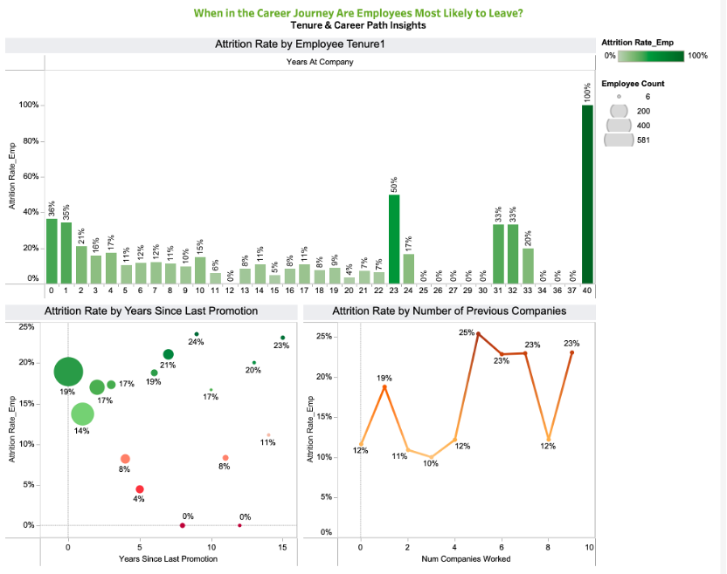

**Fig. 36**

**After:**

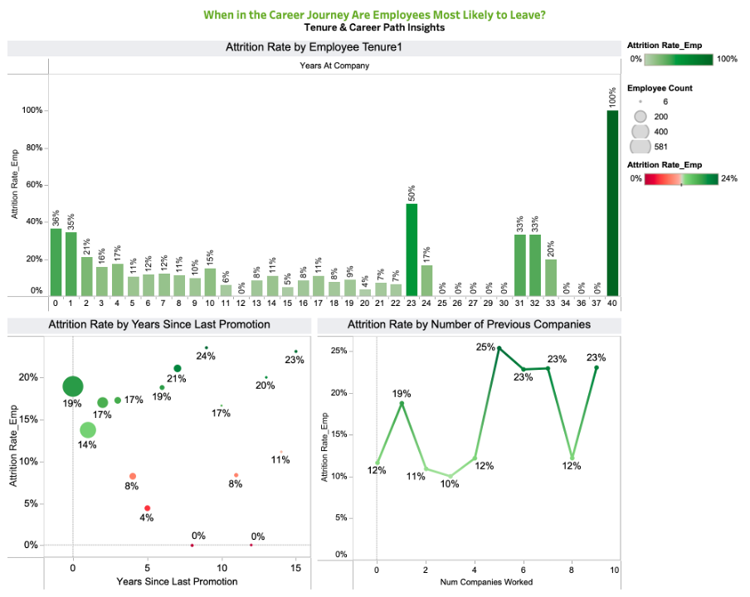 **Fig. 37**

**B. Key Visuals & Feedback-Driven Iteration**

**Theme 5.1: Tenure-Based Patterns**

**Key Visual 1: Attrition Rate by Employee Tenure (Bar Chart)**

**Insight:**  
The attrition risk is of early concentration during the lifecycle of an employee. Employees in their first year show the highest turnover rates- over and above the rates of the majority of mid-career employees. Attrition decreases gradually after Year 2, which indicates the growing organizational attachment and job fit.

**Design Rationale:**  
The sharp early decline can be physically conspicuous using a single-series bar chart. The labels of only significant peaks (Year 01) enhance better readability since it eliminates clutter.

Feedback Integration (Before/After):

* **Before:** Each of the 41 tenure values was shown with percentage labels which generated unwanted noise.
* **After:** Labels on only significant tenure peaks (e.g., 0, 1, 23, 31 -33) enhance visual attention and enhance the story on early-tenure attrition.

**Theme 5.2: Promotion Stagnation & Career Progression**

**Key Visual 2: Attrition Rate by Years Since Last Promotion (Bubble Chart)**

**Insight:**  
The attrition of employees who have not received any promotion in 4-7 years increases drastically. To a great extent, this stagnation window is congruent with the career dissatisfaction curve in most of the organizations. The number of bubbles presents the number of employees impacted, which can be seen that this high-risk window has an impact on a significant part of the workforce.

**Design Principle (Encoding):**  
We coded employee volume with bubble size and risk intensity with colour. The stagnation zone is instantly noticed by bigger and darker bubbles.

**Feedback Integration (Before/After):**

* **Before:** There was inconsistent variation in bubble colors, and this weakened the attribution of a severity of riskiness.
* **After:** A green-red gradient over all the bubbles indicates that the darker the color, the greater the attrition.

**Key Visual 3: Attrition Rate by Number of Previous Companies (Line Chart)**

**Insight:**  
Workers that have had a minimum of five former employers have a significantly increased rate of attrition. These high-mobility workers show a very steady trend of job-hopping, and they are much more likely to reoffend.

**Design Consideration:**  
A line chart that has been smoothed highlights the volatility in the attrition with the rise in the job history. The mobility trend is clear because each peak (2, 5, 7, 9 companies) is labeled without overcrowding the viewer.

**Feedback Integration (Before/After):**

* **Before:** Irregular line thickness and absence of peaks marking the positions of the mobility pattern made it blurred.
* **After:** ARRAY and targeted labelling help to identify the correlation between previous mobility and existing risk of attrition.

**C. Explicit Design Principles Applied**

**Tufte’s Graphical Integrity**

* **Data-Ink Ratio:** Removed unnecessary labels in the tenure chart in order to emphasise the steep upward pattern of the early tenure (Tufte, 2001).
* **Truthful Encoding**: To prevent alternative interpretations of the results, the calculations of attrition were displayed in both the tooltip and the annotation text.

**Cole Nussbaumer Knaflic’s Pretensive Attributes**

* **Color Intensity:**
  + The darker the tones, the greater is the attrition in all the three images.
  + Green (promotion competition-stable zones) to Red (risk zones).
  + This helps in real-time identification of career danger zones in career paths.

**Gestalt Principles**

* **Proximity & Grouping:**
  + Tenure, promotion and mobility representations were placed in a horizontal way forming a narrative that runs on history of entry progression.
  + The distance between the analytical lenses is evident yet the theme of the lifecycle remains overriding.

**Cognitive Load Reduction**

* The use of simplified labeling and color scales minimizes mental load so that users are able to concentrate on the time when the risk of attrition increases instead of spending their time on visual noise.

**Future Improvements Based on Presentation Feedback**

Based on the professor’s feedback, our team recognizes that the current presentation took a more generalized approach to interpreting the dataset. For the future, we will conduct a deeper analysis to identify patterns across different age groups, assess how incentives influence behavior, and incorporate year-over-year trends. Since the original dataset did not include a year variable, we will include it in the dataset by either engineering a time component or sourcing additional data that allows us to analyze changes over time. These improvements will help us produce a more detailed, data-driven story that not only answers the core questions but also uncovers richer patterns that support stronger business recommendations.

**Team Contributions**

|  |  |
| --- | --- |
| **Prompt** | Sibangi |
| **Report** | Sibangi, Neola, Shravya |
| **Dashboard** | |  |  | | --- | --- | | Shreenaben | Page 1 | | Sibangi | Page 2 | | Shravya | Page 3: Theme 3 | | Neola D’sa | Page 3: Theme 4 | | Vindhya | Page 4 | |
| **After Feedback** | |  |  | | --- | --- | | Shreenaben | Page 1 | | Sibangi | Page 2 | | Shravya | Page 3: Theme 3 | | Neola D’sa | Page 3: Theme 4 | | Vindhya | Page 4 | |
| **Tracking Sheet** | Sibangi, Neola, Shravya |
| **PPT** | Shreenaben, Vindhya |

**Use of AI tools**  
Disclosure: Generative AI (ChatGPT, GPT-5) was used for initial data understanding, analysis and getting feedback to enhance the visuals. Please refer to the tracking sheet for specific prompts.

**References**

Google. (2025). *Gemini* [Large language model]. <https://gemini.google.com/>

Knaflic, C. N. (2015). *Storytelling with Data: A Data Visualization Guide for Business Professionals*. Wiley.

OpenAI. (2025). *ChatGPT* (October 2 version) [Large language model]. <https://chat.openai.com/>

Tufte, E. R. (2001). *The Visual Display of Quantitative Information* (2nd ed.). Graphics Press.

Tufte, E. R. (1983). *The visual display of quantitative information.* Cheshire, CT: Graphics Press.

**Kaggle dataset**  
Konapure, R. (n.d.). *HR analytics prediction* [Dataset]. Kaggle. Retrieved September 15, 2025, from<https://www.kaggle.com/datasets/rishikeshkonapure/hr-analytics-prediction/data>

**Tableau dashboards**  
Pradeepkumar, G. (n.d.). *HR Attrition Dashboard RWFD* [Visualization]. Tableau Public. Retrieved September 28, 2025, from<https://public.tableau.com/app/profile/pradeepkumar.g/viz/HRAttritionDashboardRWFD_16570446563570/viz>

Suglani, N. (n.d.). *HR Attrition RWFD* [Visualization]. Tableau Public. Retrieved September 28, 2025, from<https://public.tableau.com/app/profile/naresh.suglani/viz/HRAttritionRWFD_16766412174060/HRAttrition>

Tableau Datafam Slack. (n.d.). *Slack archive: C08GUJGMKRN*. Retrieved September 20, 2025, from<https://tableau-datafam.slack.com/archives/C08GUJGMKRN/p1758412175661259>

**Appendix**

***Sibangi:***

**Feedback Prompt:**

*Hi Tableau community!*

*I'm a student working on an HR Attrition dashboard and would love your feedback on two of my dashboard. I'm trying to tell a story that moves from a high-level demographic profile to a more specific job-role analysis.*

*Dashboard 1: "Demographic Insights" focuses on the demographics of who is leaving (age, commute, marital status).*

*Dashboard 2: "Job & Department Profile" drills down into role-specific factors (business travel, job level, and gender by department).*

*(I've attached both links and screenshots).*

*My main questions are about consistency and clarity:*

*Does this two-page flow make sense? I'm trying to go from "general" to "specific," but I'm worried it just feels disconnected.*

*How bad is the inconsistency? I know the chart types and color schemes are all over the place (orange/blue vs. orange/brown). Does this make the dashboard confusing or unprofessional?*

*Are the charts working? I'm particularly unsure about the "Attrition Rate by Department Job Level" chart (on the 2nd page). Is it even readable, or would a simple heatmap be better?*

*I'd be grateful for any suggestions on how to create a more unified, clear, and professional-looking story across both pages. Thanks!*

*Link to viz:*

*Dashboard 1 :* [*https://public.tableau.com/views/WhoIsLeavingTheAttritionProfileDemographicInsights/DashboardStory2_1?:language=en-US&:sid=&:redirect=auth&:display_count=n&:origin=viz_share_link*](https://public.tableau.com/views/WhoIsLeavingTheAttritionProfileDemographicInsights/DashboardStory2_1?:language=en-US&:sid=&:redirect=auth&:display_count=n&:origin=viz_share_link)

*Dashboard 2 :* [*https://public.tableau.com/views/WhoIsLeavingTheAttritionProfileJobDepartmentProfile/DashboardStory2?:language=en-US&:sid=&:redirect=auth&:display_count=n&:origin=viz_share_link*](https://public.tableau.com/views/WhoIsLeavingTheAttritionProfileJobDepartmentProfile/DashboardStory2?:language=en-US&:sid=&:redirect=auth&:display_count=n&:origin=viz_share_link)***"***

**Response:**

**“***good morning - nice work but there are some issues:*

* *It looks like the data represents a single year - i.e there is no date associated with the calculations - so you are look at the number of leaving versus the TOTAL emps in the data - best practice is to include that in the sheet not in a caption that is not visible to the viewer*
* *in some of the charts you are using sum(emp number) as an axis - should be a countd()*
* *I think I mentioned this in a previous version - you can create a donut chart from scratch not from a viz ext that renders a chart that is not visible to the viewer -*
* *also the Donut chart proportions and tooltip number are not consistent - something is wrong -*
* *the stacked bar chart is misleading - a sxs bar chart is a better representation of the data - further the ref line is an average of ALL 3 departments - you should make the value department specific - also you imply it is an overall industry average - it is the average of only the data from 3 departments and not an overall industry average of all workers within the industry*

*It is important to have the data and the analysis correct and then develop the story to present the insights -*

*Look forward to seeing the next iteration”*

**Impact of Changes:**

These revisions significantly improved the final output in three key areas:

*Accuracy:* The most critical fix was technical. Changing the measure from SUM to COUNTD prevented the reporting of erroneous headcount numbers. Additionally, correcting the "Industry Benchmark" reference line from a dynamic average (which falsely implied internal performance was the standard) to a hard-coded constant (15%) allowed for true performance evaluation.

*Clarity:* The feedback regarding the "Job Level" chart led to the implementation of a Highlight Table/Heatmap. This removes visual clutter and immediately draws the viewer's eye to the "red zones" (Level 1 employees), reducing the time-to-insight

*Impact:* By adopting GenAI's advice on intersectionality, the report moved from a passive description ("Sales is losing people") to a diagnostic conclusion ("We are losing young, single men in Sales and women in HR"). This allows stakeholders to create targeted retention programs rather than generic ones.

**Tableau Link before feedback:**  
<https://public.tableau.com/views/WhoIsLeavingTheAttritionProfileDemographicInsights/DashboardStory2_1?:language=en-US&:sid=&:redirect=auth&:display_count=n&:origin=viz_share_link>

<https://public.tableau.com/views/WhoIsLeavingTheAttritionProfileJobDepartmentProfile/DashboardStory2?:language=en-US&:sid=&:redirect=auth&:display_count=n&:origin=viz_share_link>

**Tableau Link after feedback:**  
<https://public.tableau.com/views/WhoIsLeavingTheAttritionProfileJobDepartmentProfile_afterfeedback/SibangiDashboardStory2?:language=en-US&publish=yes&:sid=&:redirect=auth&:display_count=n&:origin=viz_share_link>

<https://public.tableau.com/views/WhoIsLeavingTheAttritionProfileDemographicInsights_afterfeedback/SibangiDashboardStory2_1?:language=en-US&publish=yes&:sid=&:redirect=auth&:display_count=n&:origin=viz_share_link>

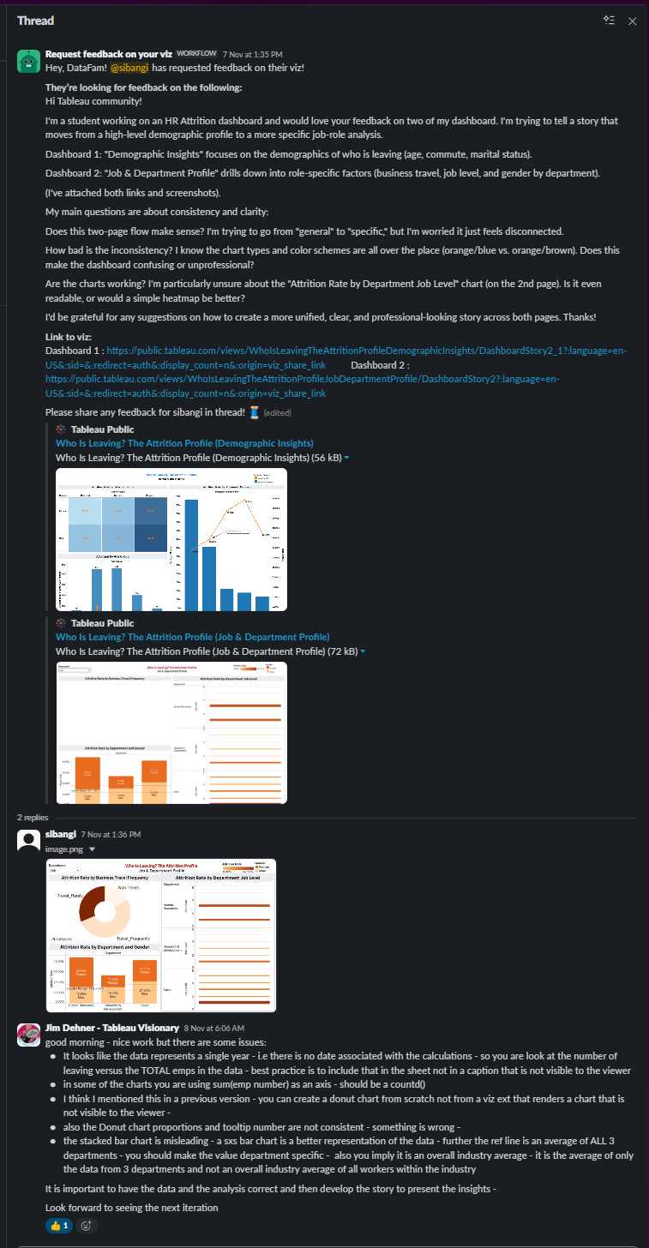 **Fig. 38**

***Prompt 1:***

*"I am designing a comprehensive Tableau story for an HR Attrition analysis. I have already brainstormed a list of analysis questions and grouped them into 5 themes (Demographics, Job Role, Financials, Satisfaction, and Career Journey).*

*I have these 20 questions:*

1. *What’s the company’s overall attrition rate?*
2. *How does the attrition vary across different Age Groups?*
3. *Is there a gender disparity in attrition rates within different Departments?*
4. *Are single employees more likely to leave the company than married or divorced employees?*
5. *How does Distance From Home correlate with the likelihood of attrition?*
6. *Which Job Roles have the highest and lowest attrition rates?*
7. *Are employees who work OverTime significantly more likely to leave?*
8. *What is the relationship between Job Level and attrition?*
9. *How does the frequency of Business Travel impact the attrition rate?*
10. *Which Department is facing the most significant attrition challenge?*
11. *How does Monthly Income for employees who leave compare to those who stay?*
12. *Does a lower Percent Salary Hike correspond to a higher probability of attrition?*
13. *Does a higher Stock Option Level correlate with lower attrition?*
14. *What is the impact of Job Satisfaction on attrition?*
15. *How do Work-Life Balance ratings differ between employees who stay and those who leave?*
16. *Is there a connection between an employee’s Performance Rating and their decision to leave?*
17. *Is a low combined satisfaction score a strong indicator of potential attrition?*
18. *At what point in an employee’s tenure (Years At Company) is attrition most likely to occur?*
19. *How does the time since last promotion (Years Since Last Promotion) affect attrition rates?*
20. *Do employees who have worked at more companies previously (Num Companies Worked) have a higher attrition rate?*

*Organize these questions into a 5-Page Report Outline for a senior stakeholder, moving from the 'Big Picture' to 'Root Causes' and then 'Intervention’.”*

***Response:***

“*Page 1: The Big Picture: Attrition Overview*

*Goal: To immediately convey the scale of the attrition problem and highlight the top-level drivers.*

*Visualizations:*

* *KPI Banner*
  + *Caption (KPI 1): Overall Attrition Rate*
  + *Source Question: (Theme 1, Q1) What's the company's overall attrition rate?*
* *Top Driver Charts*
  + *Chart 1 Title: Attrition Rate by Overtime*
  + *Source Question: (Theme 2, Q7) Hypothesis: Employees who work OverTime are significantly more likely to leave.*
  + *Chart 2 Title: Attrition Rate by Job Role*
  + *Source Question: (Theme 2, Q6) Which Job Roles have the highest and lowest attrition rates?*
  + *Chart 3 Title: Attrition Rate by Job Satisfaction*
  + *Source Question: (Theme 4, Q14) What is the impact of Job Satisfaction on attrition?*

*Page 2: Who Is Leaving? The Attrition Profile*

*Goal: To identify the specific demographic and professional segments of the workforce that are most at risk.*

*Visualizations:*

* *Demographic Insights (Theme 1)*
  + *Chart 1 Title: Attrition Rate by Age Group*
  + *Source Question: (Theme 1, Q2) How does the attrition rate vary across different Age Groups?*
  + *Chart 2 Title: Attrition Rate by Marital Status*
  + *Source Question: (Theme 1, Q4) Hypothesis: Single employees are more likely to leave...*
  + *Chart 3 Title: Attrition Rate by Commute Distance*
  + *Source Question: (Theme 1, Q5) How does Distance From Home correlate with the likelihood of attrition?*
* *Job & Department Profile (Theme 2)*
  + *Chart 4 Title: Attrition by Department & Gender*
  + *Source Question: (Theme 1, Q3) Is there a gender disparity in attrition rates within different Departments?*
  + *Chart 5 Title: Attrition Rate by Department*
  + *Source Question: (Theme 2, Q10) Which Department is facing the most significant attrition challenge?*
  + *Chart 6 Title: Attrition Rate by Job Level*
  + *Source Question: (Theme 2, Q8) What is the relationship between Job Level and attrition?*
  + *Chart 7 Title: Attrition Rate by Business Travel Frequency*
  + *Source Question: (Theme 2, Q9) How does the frequency of Business Travel impact the attrition rate?*

*Page 3: Why Are They Leaving? Root Cause Analysis*

*Goal: To uncover the underlying reasons for turnover, focusing on compensation and employee sentiment.*

*Visualizations:*

* *Compensation & Financials (Theme 3)*
  + *Chart 1 Title: Monthly Income Distribution: Attrited vs. Retained*
  + *Source Question: (Theme 3, Q11) How does Monthly Income for employees who leave compare to those who stay?*
  + *Chart 2 Title: Attrition Rate by Percent Salary Hike*
  + *Source Question: (Theme 3, Q12) Hypothesis: A lower Percent Salary Hike corresponds to a higher probability of attrition.*
  + *Chart 3 Title: Attrition Rate by Stock Option Level*
  + *Source Question: (Theme 3, Q13) Does a higher Stock Option Level correlate with lower attrition?*
* *Satisfaction & Engagement (Theme 4)*
  + *Chart 4 Title: Average Work-Life Balance: Attrited vs. Retained*
  + *Source Question: (Theme 4, Q15) How do Work-Life Balance ratings differ between employees who stay and those who leave?*
  + *Chart 5 Title: Attrition Rate by Overall Satisfaction Level*
  + *Source Question: (Theme 4, Q17) Hypothesis: A low combined satisfaction score is a strong indicator of potential attrition.*
  + *Chart 6 Title: Attrition Rate by Performance Rating*
  + *Source Question: (Theme 4, Q16) Is there a connection between an employee's Performance Rating and their decision to leave?*

*Page 4: When & What's Next? The Employee Journey*

*Goal: To identify critical intervention points in an employee's career and provide data-driven recommendations.*

*Visualizations:*

* *Tenure & Career Path (Theme 5)*
  + *Chart 1 Title: Attrition Rate by Employee Tenure*
  + *Source Question: (Theme 5, Q18) At what point in an employee's tenure (Years At Company) is attrition most likely to occur?*
  + *Chart 2 Title: Attrition Rate by Years Since Last Promotion*
  + *Source Question: (Theme 5, Q19) How does the time Years Since Last Promotion affect attrition rates?*
  + *Chart 3 Title: Attrition Rate by Number of Previous Companies*
  + *Source Question: (Theme 5, Q20) Do employees who have worked at more companies previously... have a higher attrition rate?”(Google, 2025)*

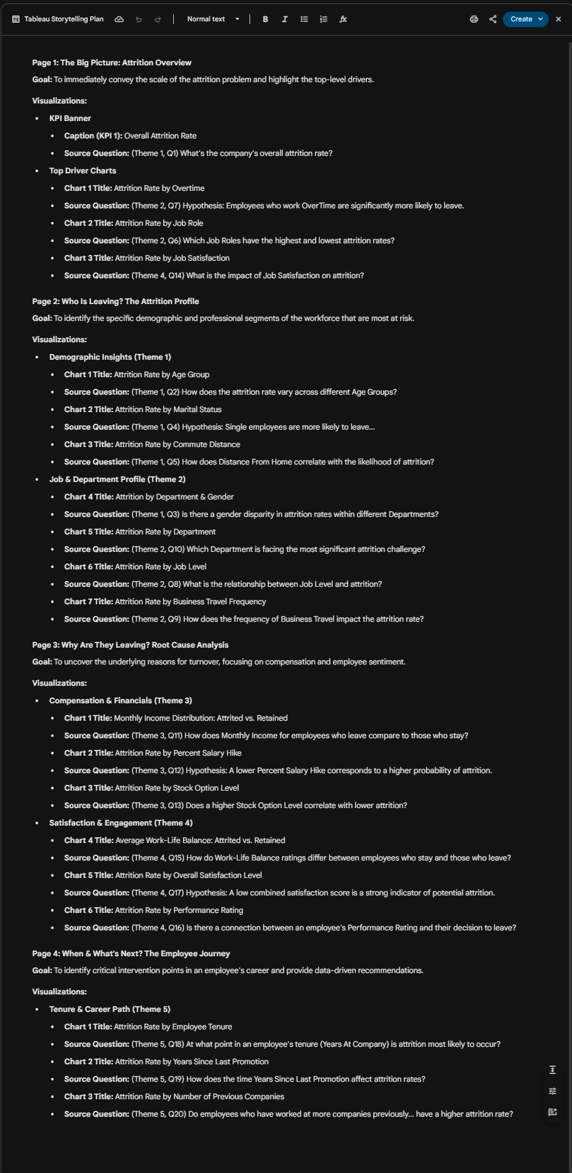

**Fig. 39**

***Prompt 2:***

*“Act as a Data Visualization Mentor. Review the attached dashboard screenshots and provide feedback, specifically highlighting the layout, the effective use of color intensity to show risk, the storytelling flow between the two pages, and the value of the added contextual details like reference lines.”*

***Response:***

*“These are looking great! Here is some quick positive feedback:*

* *Clean Layout: Both dashboards are very well-organized. The grid structure makes it easy to scan the information without feeling overwhelmed.*
* *Effective Color Use: You’ve used color intensity meaningfully—it’s immediately obvious where the "problem areas" are (like the dark blue for single employees or the dark orange for HR Level 1) because the eye is drawn to the darker saturation.*
* *Strong Storytelling: Separating "Demographic Insights" from "Job & Department Profile" creates a logical flow. You start with who they are, and then move to what they do.*
* *Contextual Details: The "Industry Range" reference line and the explanatory footnote on the second dashboard are fantastic additions. They give the viewer the necessary context to understand why the numbers matter.*

*Excellent work on the iteration!”(Google, 2025)*

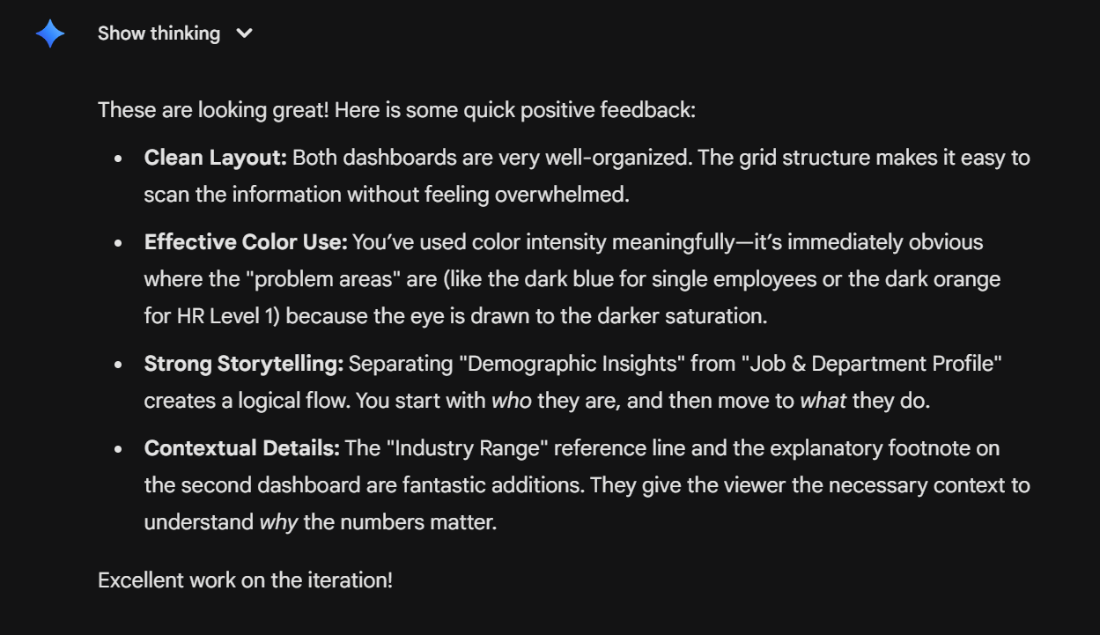

**Fig. 40**

***Neola:***

**Feedback Prompt:**  
  
 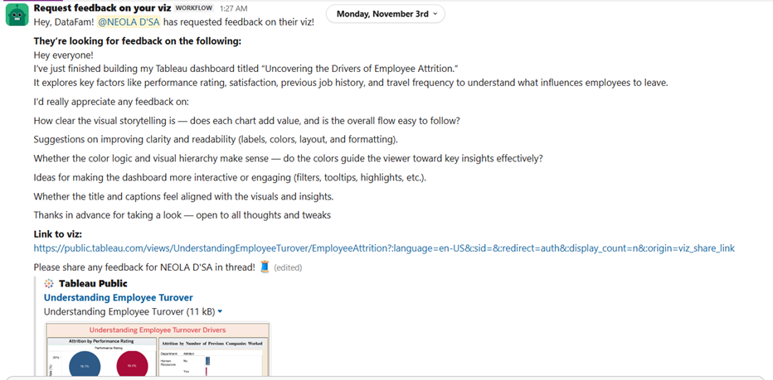

**Fig. 41**

**Tableau Link before feedback:**<https://public.tableau.com/views/EmployeeTurnoverDrivers/EmployeeAttrition?:language=en-US&:sid=&:redirect=auth&:display_count=n&:origin=viz_share_link>**Tableau Link after feedback:** <https://public.tableau.com/app/profile/sibangi.subhadarsani/viz/Atttrition/Dashboardstory3>

**Impact of Changes:**

These revisions significantly improved the final output in three key areas:

*Accuracy:* Removed the average attrition and rebuilt the satisfaction so employee counts give us accurate and high-risk flags with weighted understanding of risk. Fixed incorrect metrics so they represent true attrition rate and added parameters to reflect accurate, comparable aggregations.

*Clarity:* Added a 3.0 healthy satisfaction threshold to help users understand which satisfaction categories fall. Used colour encoding blue for retained and orange for attrited and added headcount of employees.

*Impact:* It gave diagnostic insights where employees who leave score lower across every metric with Job satisfaction as the most alarming predictor. Even a small cluster of highly dissatisfied (18 in level 1) drives attrition risk. They highlight root causes and not just patterns allowing leaders to target investments around job design, workload balance and role satisfaction.

***Shravya:***

**Feedback Prompt:**

**Fig. 42**

**Slack Post Feedback Link:**

<https://tableau-datafam.slack.com/archives/C08GUJGMKRN/p1763269566016249>

**Tableau Link Before Feedback:**

<https://public.tableau.com/app/profile/shravya.thangamma.kechamada.sharath/viz/Assignment2_17632639391780/DashboardInsightsIntoEmployeeAttritionDrivers>

**Tableau Link Before Feedback:**

<https://public.tableau.com/views/WhoIsLeavingTheAttritionProfileJobDepartmentProfile_17645766269310/Dashboard5?:language=en-US&publish=yes&:sid=&:redirect=auth&:display_count=n&:origin=viz_share_link>

**Impact of Changes:**

*Accuracy:* I changed the shade of blue in the histogram, which gave me a stronger contrast between the colors, improving the visual accuracy. I also added average attrition lines which improves accuracy by having a reference point against overall attrition.

*Clarity:* Rotated the bars on the histogram and added outlines to them which reduced ambiguity and allows a clearer distinction between attrited vs. retained employees. Changing the color theme of the dashboard from purple to blue really helped bring it all together and make it more cohesive.

*Impact:* The revision made an impact on my dashboard because it highlights the differences between attrited and retained employees much better. It makes it clear for the viewer that attrition is more common among lower-income employees with small salary hikes.

***Vindhya:***

**Feedback Prompt:**  
  
 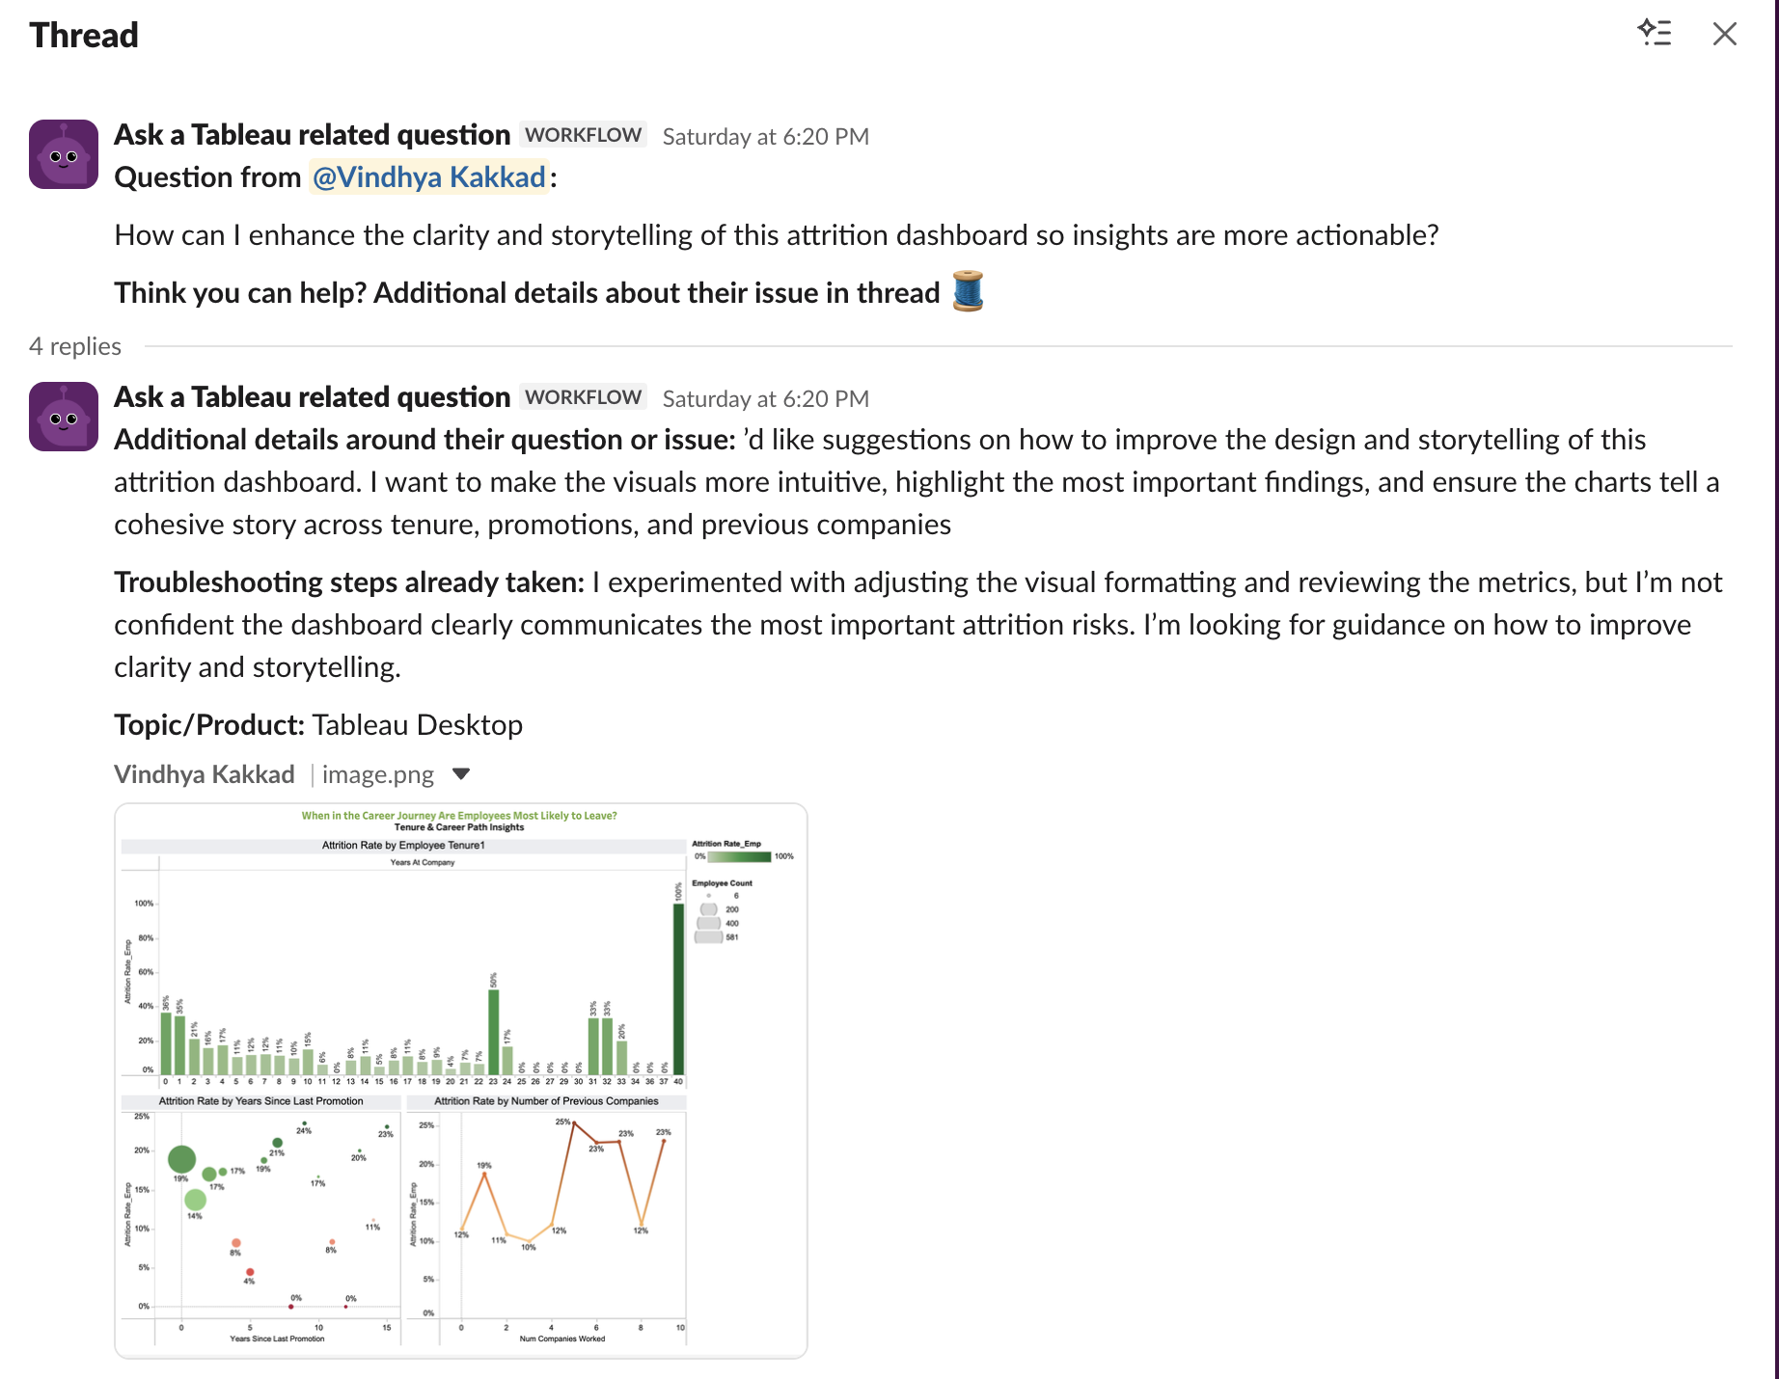

**Fig. 43**

**Slack Post Feedback Link:**

<https://tableau-datafam.slack.com/archives/C08G64NNYDQ/p1764462026133949>

**Impact of Changes:**

After incorporating the visual feedback, the dashboard became significantly clearer and easier to interpret. The dashboards are now visually organized, easy to understand and use. By clustering employees within employer tenure groups and decreasing the overall number of data labels, the dashboard provides a much more aesthetically pleasing "open" appearance, and at the same time creates much larger "gaps" between high and low attrition count. The use of a consistent colour theme across the dashboards further develops continuity with the stories being communicated by way of visualisation. By aligning gridlines, axis scale and titles, there is increased visual clarity when comparing charts within each chart category. The addition of more space between the charts and moving the legend into a more visually balanced position greatly reduced the feeling of clutter in the dashboards and has resulted in a much more professionally designed dashboard. Overall, the outcome of these enhancements is that stakeholders will be able to better utilise the information represented visually and make informed decisions based on the information presented, thus allowing them to create "quick actionable insights" from the dashboards.

***Shreenaben:***

**Feedback Prompt:**

"I am designing the Big Picture overview page for an HR Attrition Tableau Story.   
Please review the KPI banner and my three top-driver charts (Overtime, Job Role, Job Satisfaction).   
Provide feedback on clarity, visual design, storytelling flow, and whether the insights align with best practices for an executive overview."

**Feedback Post of Tableau Slack community**

*"Hey, DataFam! @Shreena has requested feedback on their viz!*

*They’re looking for feedback on the following:*

*Hi Tableau community!*

*I'm a student working on an HR Attrition dashboard and would love your feedback on two of my dashboard. I'm trying to tell a story that moves from a high-level demographic profile to a more specific job-role analysis.*

*(I've attached both links and screenshots).*

*My question:*

*Do the colors I used make sense for the story I’m trying to tell, or should I revise them for better clarity and consistency?*

*Is the layout easy to follow, or should I reorganize the charts?*

*Does the dashboard tell a clear story from start to end?*

*Are the chart types appropriate for the insights I'm trying to show?*

*Is the information too crowded, or is the spacing okay?*  *I'd be grateful for any suggestions on how to create a more unified, clear, and professional-looking story across both pages. Thanks!”*

**Fig. 44**

**Impact of Changes:**

*Accuracy:* I corrected the KPI and driver charts to ensure the measures reflected true attrition rates rather than raw counts or misleading averages. The attrition logic was rebuilt using accurate calculated fields, and unnecessary aggregation errors were removed. Sorting the Job Role chart by attrition rate provided a more precise representation of high-risk roles, and the overtime analysis was simplified to show the correct percentage difference between “Yes” and “No” employees.

*Clarity:* I streamlined all visuals by removing clutter such as gridlines and excessive labels, making the insights easier to read. Job Satisfaction categories were renamed from numeric codes to “Low / Medium / High / Very High,” improving interpretability. The dashboard was reorganized into a clean top-to-bottom flow from KPI to Overtime to Job Role to Satisfaction, so viewers could quickly understand the big picture without scanning multiple directions.

*Impact:* These improvements transformed the overview dashboard into a true executive summary. The results now clearly highlight that overtime, job role, and satisfaction are the strongest early indicators of attrition. The dramatic contrast between overtime groups and the steep drop in satisfaction among attrited employees provides immediate diagnostic insight. This helps leaders quickly recognize systemic risks - such as workload pressure and dissatisfaction, so they can prioritize interventions focused on work-life balance, employee experience, and role-specific support.